NWPNET023 Maintain and repair network assets for wastewater
Release: 1

NWPNET023 Maintain and repair network assets for wastewater

Modification History
Release | Comments
1 | This unit was released in NWP Water Training Package release 1.0 and meets the Standards for Training Packages.  - New unit, created drawing upon information from deleted units NWP255B, NWP257B, NWP253B and NWP229B

Application
This unit describes the skills required to maintain and repair pipes, drains and wastewater collection assets.
This unit applies to those working as field staff with specific responsibility for ensuring that repair and maintenance of wastewater assets is completed in a safe and timely manner.
The skills and knowledge described in this unit must be applied within the legislative, regulatory and policy environment in which they are carried out. Organisational policies and procedures must be consulted and adhered to.
Those undertaking this unit would work under indirect supervision, while performing routine tasks, in a familiar context, ensuring minimum damage to the environment.
No licensing, legislative or certification requirements apply to unit at the time of publication.

Competency Field
Networks

Elements and Performance Criteria
ELEMENTS | PERFORMANCE CRITERIA
Elements describe the essential outcomes | Performance criteria describe the performance needed to demonstrate achievement of the element. Where bold italicised text is used, further information is detailed in the range of conditions section.
1. Plan and prepare for work | 1.1 Conduct risk assessment for environmental and safety factors.  1.2 Determine work requirements, materials and configuration from plans, specifications, instructions and/or organisational procedures.  1.3 Check coordination issues with relevant personnel, including isolations, licences and permits to work.  1.4 Identify networks system operation requirements.  1.5 Arrange remove site protection.
2. Conduct maintenance | 2.1 Isolate the work area.  2.2 Determine appropriate repair method from job specifications and instructions.  2.3 Maintain and repair structural damage to assets.  2.4 Check maintenance and repairs to assets to ensure specifications are met.  2.5 Restore work site to meet environmental and organisational requirements.
3. Review, report and record work | 3.1 Check, tag and report faulty equipment and tools.  3.2 Store equipment, tools and materials.  3.3 Complete and process workplace records.

Foundation Skills
The foundation skills demands of this unit have been mapped for alignment with the Australian Core Skills Framework (ACSF). The following tables outline the performance levels indicated for successful attainment of the unit.

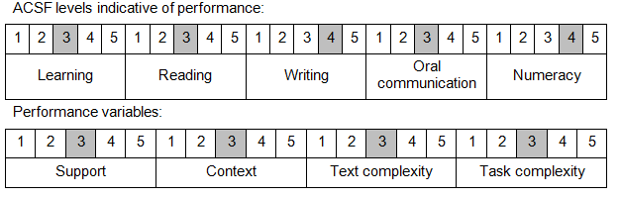

Further information on ACSF and the foundation skills underpinning this unit can be found in the Foundation Skills Guide on the GSA website.

Range of Conditions
Network assets includes: | - water mains  - connections  - pump stations

Unit Mapping Information
No equivalent unit.

Links
Companion Volume implementation guides are found in VETNet - https://vetnet.gov.au/Pages/TrainingDocs.aspx?q=26336bc0-04e5-49d9-8c31-46c49b6a0037
Companion Volume implementation guides are found in VETNet - https://vetnet.gov.au/Pages/TrainingDocs.aspx?q=26336bc0-04e5-49d9-8c31-46c49b6a0037
Companion Volume implementation guides are found in VETNet - https://vetnet.gov.au/Pages/TrainingDocs.aspx?q=26336bc0-04e5-49d9-8c31-46c49b6a0037
Companion Volume implementation guides are found in VETNet - https://vetnet.gov.au/Pages/TrainingDocs.aspx?q=26336bc0-04e5-49d9-8c31-46c49b6a0037

