NWPNET017 Supervise and report on conduit inspections
Release: 1

NWPNET017 Supervise and report on conduit inspections

Modification History
Release | Comments
1 | This unit was released in NWP Water Training Package release 1.0 and meets the Standards for Training Packages.  This unit supersedes and is equivalent to NWP440A Supervise conduit inspection and reporting.  - Unit code updated  - Content and formatting updated to comply with the new standards  - All PC transitioned from passive to active voice  - Unit title changed to better reflect unit outcomes

Application
This unit describes the skills required to supervise or manage the inspection and reporting of the condition and features in sewer and stormwater conduits using specialised CCTV equipment.
This unit applies to those who supervise or manage work involved in the inspection and reporting of the condition and features in sewer and stormwater conduits using specialised CCTV equipment. It is also applicable to people who prepare inspection reports from data supplied by specialised CCTV sewer inspection operators.
The skills and knowledge described in this unit must be applied within the legislative, regulatory and policy environment in which they are carried out. Organisational policies and procedures must be consulted and adhered to, particularly those related to industry codes and specifications.
Those undertaking this unit would work independently or in a team and the level of responsibility may vary according to the size, scope, location, and technical complexity of process. They would perform complex tasks in familiar contexts while ensuring minimum damage to the environment.
No licensing, legislative or certification requirements apply to unit at the time of publication.

Competency Field
Networks

Elements and Performance Criteria
ELEMENTS | PERFORMANCE CRITERIA
Elements describe the essential outcomes | Performance criteria describe the performance needed to demonstrate achievement of the element. Where bold italicised text is used, further information is detailed in the range of conditions section.
1. Determine inspection reporting requirements | 1.1 Determine the inspection reporting standard and special inspection and reporting requirements of the client or asset owner from specifications and instructions.  1.2 Obtain plans and maps of assets to be inspected and identify relevant asset data.  1.3 Seek clarification of inspection reporting requirements from the client/asset owner for unusual or non-routine inspections.  1.4 Verify the competence of operators undertaking the inspection.
2. Review video images, data and reports from inspections | 2.1 Check video records of inspections.  2.2 Compile documentation from inspection and check for completeness and accuracy.  2.3 Recognise unsatisfactory video images and other non-compliant data and submit non-compliance reports to the operator.  2.4 Label and reference inspection information.
3. Identify and code defects and other features from video images of conduit inspection | 3.1 Identify and code structural defects, service conditions and other features of the conduit.  3.2 Record asset and inspection data using appropriate software.  3.3 Investigate and report unrecognisable defects, service conditions or other features.  3.4 Identify a conduit at risk of imminent failure and communicate details to the system operator/asset owner.  3.5 Confirm defects or malfunctioning of maintenance holes, pits or other access structures with the operator and report.
4. Prepare conduit inspection reports for client | 4.1 Compile inspection reports and present to the client.  4.2 Follow inspection video and data security procedures.

Foundation Skills
The foundation skills demands of this unit have been mapped for alignment with the Australian Core Skills Framework (ACSF). The following tables outline the performance levels indicated for successful attainment of the unit

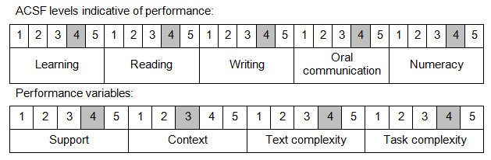

Further information on ACSF and the foundation skills underpinning this unit can be found in the Foundation Skills Guide on the GSA website.

Unit Mapping Information
This unit supersedes and is equivalent to NWP440A Supervise conduit inspection and reporting.

Links
Companion Volume implementation guides are found in VETNet - https://vetnet.gov.au/Pages/TrainingDocs.aspx?q=26336bc0-04e5-49d9-8c31-46c49b6a0037
Companion Volume implementation guides are found in VETNet - https://vetnet.gov.au/Pages/TrainingDocs.aspx?q=26336bc0-04e5-49d9-8c31-46c49b6a0037
Companion Volume implementation guides are found in VETNet - https://vetnet.gov.au/Pages/TrainingDocs.aspx?q=26336bc0-04e5-49d9-8c31-46c49b6a0037
Companion Volume implementation guides are found in VETNet - https://vetnet.gov.au/Pages/TrainingDocs.aspx?q=26336bc0-04e5-49d9-8c31-46c49b6a0037

