NWPNET015 Perform leak detection
Release: 1

NWPNET015 Perform leak detection

Modification History
Release | Comments
1 | This unit was released in NWP Water Training Package release 1.0 and meets the Standards for Training Packages.  This unit supersedes and is equivalent to NWP339B Perform leak detection.  - Unit code updated  - Content and formatting updated to comply with the new standards  - All PC transitioned from passive to active voice  - Elements 2 and 3 merged  - PC 3.1 and 3.2 merged

Application
This unit describes the outcomes required to plan leak detection activities and to locate, identify and report leaks in water distribution networks (pressure mains).
This unit applies to those working as field staff with a specific responsibility for planning and implementing leak detection activities.
The skills and knowledge described in this unit must be applied within the legislative, regulatory and policy environment in which they are carried out. Organisational policies and procedures must be consulted and adhered to, particularly those related to WHS.
Those undertaking this unit would work under indirect supervision, while performing routine tasks in a familiar context, ensuring minimum damage to the environment.
No licensing, legislative or certification requirements apply to unit at the time of publication.

Competency Field
Networks

Elements and Performance Criteria
ELEMENTS | PERFORMANCE CRITERIA
Elements describe the essential outcomes | Performance criteria describe the performance needed to demonstrate achievement of the element. Where bold italicised text is used, further information is detailed in the range of conditions section.
1. Plan for leak detection | 1.1 Determine work site boundaries and leak detection requirements from plans, specifications and instructions.  1.2 Select and check equipment.  1.3 Plan for leak detection using site inspection and service search diagrams according to work site requirements.
2. Operate leak detection equipment and report work | 2.1 Determine and mark work site boundaries from plans and service search diagrams.  2.2 Select, fit and use personal protective equipment.  2.3 Operate leak detection equipment.  2.4 Mark the location of leaks.  2.5 Expose leaks and arrange repair according to testing outcomes and organisational and statutory requirements.  2.6 Review, record and report work.

Foundation Skills
The foundation skills demands of this unit have been mapped for alignment with the Australian Core Skills Framework (ACSF). The following tables outline the performance levels indicated for successful attainment of the unit.

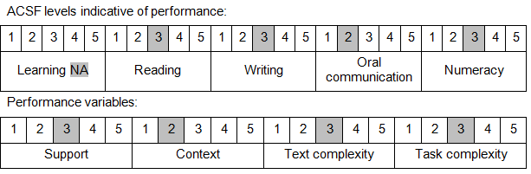

Further information on ACSF and the foundation skills underpinning this unit can be found in the Foundation Skills Guide on the GSA website.

Unit Mapping Information
This unit supersedes and is equivalent to NWP339B Perform leak detection.

Links
Companion Volume implementation guides are found in VETNet - https://vetnet.education.gov.au/Pages/TrainingDocs.aspx?q=26336bc0-04e5-49d9-8c31-46c49b6a0037
Companion Volume implementation guides are found in VETNet - https://vetnet.education.gov.au/Pages/TrainingDocs.aspx?q=26336bc0-04e5-49d9-8c31-46c49b6a0037
Companion Volume implementation guides are found in VETNet - https://vetnet.education.gov.au/Pages/TrainingDocs.aspx?q=26336bc0-04e5-49d9-8c31-46c49b6a0037
Companion Volume implementation guides are found in VETNet - https://vetnet.education.gov.au/Pages/TrainingDocs.aspx?q=26336bc0-04e5-49d9-8c31-46c49b6a0037

