NWPNET005 Optimise network systems
Release: 1

NWPNET005 Optimise network systems

Modification History
Release | Comments
1 | This unit was released in NWP Water Training Package release 1.0 and meets the Standards for Training Packages.  This unit supersedes and is equivalent to NWP403A Investigate and plan the optimisation of potable water distribution systems.  - Unit code updated  - Content and formatting updated to comply with the new standards  - All PC transitioned from passive to active voice  - Unit title changed to better reflect unit outcomes

Application
This unit describes the skills required to coordinate, monitor and optimise system performance and maintenance planning in potable water distribution systems.
This unit applies to those working as staff members with a specific responsibility for ensuring that potable water systems comply with organisational and statutory requirements.
The skills and knowledge described in this unit must be applied within the legislative, regulatory and policy environment in which they are carried out. Organisational policies and procedures must be consulted and adhered to, particularly those related to WHS.
Those undertaking this unit would work independently or in a team, and may be responsible for the coordination of an operational team. They will perform complex tasks in a familiar context, ensuring minimum damage to the environment.
No licensing, legislative or certification requirements apply to unit at the time of publication.

Competency Field
Networks

Elements and Performance Criteria
ELEMENTS | PERFORMANCE CRITERIA
Elements describe the essential outcomes | Performance criteria describe the performance needed to demonstrate achievement of the element. Where bold italicised text is used, further information is detailed in the range of conditions section.
1. Evaluate potable water distribution system performance | 1.1 Review existing distribution system performance data against relevant organisational and legislative requirements.  1.2 Identify the impact of the distribution system on water quality.  1.3 Identify and coordinate any additional sampling and testing required for valid evaluation of current process performance.
2. Investigate water distribution system issues | 2.1 Review existing system fault reports and relevant water quality information.  2.2 Identify and record links between operational problems and maintenance activities.  2.3 Investigate the operational status of system components with reference to manufacturer and supplier specifications.  2.4 Carry out distribution system configuration investigations to identify potential deficiencies.
3. Plan optimisation of potable water distribution system | 3.1 Identify potential hazards to the distribution system.  3.2 Select appropriate preventive measures.  3.3 Develop and validate a system optimisation plan.

Foundation Skills
The foundation skills demands of this unit have been mapped for alignment with the Australian Core Skills Framework (ACSF). The following tables outline the performance levels indicated for successful attainment of the unit.

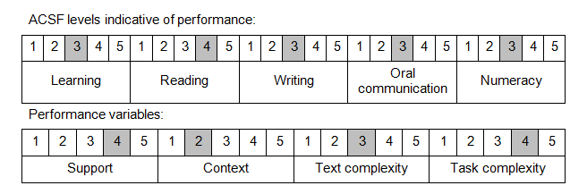

Further information on ACSF and the foundation skills underpinning this unit can be found in the Foundation Skills Guide on the GSA website.

Unit Mapping Information
This unit supersedes and is equivalent to NWP403A Investigate and plan the optimisation of potable water distribution systems.

Links
Companion Volume implementation guides are found in VETNet - https://vetnet.gov.au/Pages/TrainingDocs.aspx?q=26336bc0-04e5-49d9-8c31-46c49b6a0037
Companion Volume implementation guides are found in VETNet - https://vetnet.gov.au/Pages/TrainingDocs.aspx?q=26336bc0-04e5-49d9-8c31-46c49b6a0037
Companion Volume implementation guides are found in VETNet - https://vetnet.gov.au/Pages/TrainingDocs.aspx?q=26336bc0-04e5-49d9-8c31-46c49b6a0037
Companion Volume implementation guides are found in VETNet - https://vetnet.gov.au/Pages/TrainingDocs.aspx?q=26336bc0-04e5-49d9-8c31-46c49b6a0037

