NWPNET003 Control electrical risk on metallic pipes
Release: 1

NWPNET003 Control electrical risk on metallic pipes

Modification History
Release | Comments
1 | This unit was released in NWP Water Training Package release 1.0 and meets the Standards for Training Packages.

Application
This unit describes the skills required to safe guard work on metallic pipes.
This unit applies to those working as field and operational staff with responsibility for the control measures of high risk electrical hazards.
The skills and knowledge described in this unit must be applied within the legislative, regulatory and policy environment in which they are carried out. Organisational policies and procedures must be consulted and adhered to.
Those undertaking this unit would work independently under indirect supervision while performing routine tasks with a moderate level of complexity in a familiar context.
No licensing, legislative or certification requirements apply to unit at the time of publication.

Competency Field
Networks

Elements and Performance Criteria
ELEMENTS | PERFORMANCE CRITERIA
Elements describe the essential outcomes | Performance criteria describe the performance needed to demonstrate achievement of the element. Where bold italicised text is used, further information is detailed in the range of conditions section.
1. Plan and prepare for work | 1.1 Identify and locate area of work from job specifications.  1.2 Conduct risk assessment for environmental safety.  1.3 Select safety equipment and fit and use personal protective equipment.  1.4 Select and use electrical safety equipment.  1.5 Identify yourself to your customers and determine customer needs.
2. Assess metallic pipes for electricity | 2.1 Use electrical testing device to check for presence of electricity on metallic water pipe.  2.2 Follow organisational procedures when electricity is detected.  2.3 Identify and clean attachment points and apply bridging conductors if no electricity is detected.  2.4 Continue to enforce electrical control measures.
3. Finalise work | 3.1 Store and secure equipment and materials.  3.2 Restore work site to meet environmental and organisational requirements.  3.3 Report and tag any damaged or faulty equipment.

Foundation Skills
The foundation skills demands of this unit have been mapped for alignment with the Australian Core Skills Framework (ACSF). The following tables outline the performance levels indicated for successful attainment of the unit.

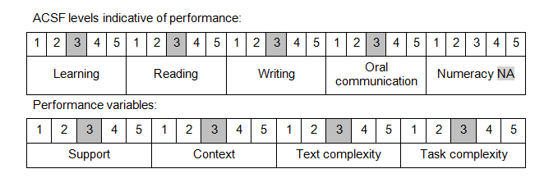

Further information on ACSF and the foundation skills underpinning this unit can be found in the Foundation Skills Guide on the GSA website.

Unit Mapping Information
No equivalent unit.

Links
Companion Volume implementation guides are found in VETNet - https://vetnet.education.gov.au/Pages/TrainingDocs.aspx?q=26336bc0-04e5-49d9-8c31-46c49b6a0037
Companion Volume implementation guides are found in VETNet - https://vetnet.education.gov.au/Pages/TrainingDocs.aspx?q=26336bc0-04e5-49d9-8c31-46c49b6a0037
Companion Volume implementation guides are found in VETNet - https://vetnet.education.gov.au/Pages/TrainingDocs.aspx?q=26336bc0-04e5-49d9-8c31-46c49b6a0037
Companion Volume implementation guides are found in VETNet - https://vetnet.education.gov.au/Pages/TrainingDocs.aspx?q=26336bc0-04e5-49d9-8c31-46c49b6a0037

