NWPIRR073 Implement and coordinate catchment management plan
Release: 1

NWPIRR073 Implement and coordinate catchment management plan

Modification History
Release | Comments
1 | This unit was released in NWP Water Training Package release 1.0 and meets the Standards for Training Packages.  This unit supersedes and is equivalent to NWP512B Implement and manage catchment management plan.  - Unit code updated  - Content and formatting updated to comply with the new standards  - All PC transitioned from passive to active voice  - Unit title changed to better reflect unit outcomes  - Element 4 reworded  - PC 1.6 removed  - PC 2.2 and 2.4 merged

Application
This unit describes the skills required to implement and coordinate activities in water catchments that impact on water yield and/or quality, to ensure performance measures for the catchment management plan are met.
This unit applies to those working as managers in water organisations with responsibility for the management of water catchments.
The skills and knowledge described in this unit must be applied within the legislative, regulatory and policy environment in which they are carried out. Organisational policies and procedures must be consulted and adhered to.
Those undertaking this unit would work autonomously, managing staff, while performing sophisticated tasks in a range of familiar contexts.
No licensing, legislative or certification requirements apply to unit at the time of publication.

Competency Field
Irrigation

Elements and Performance Criteria
ELEMENTS | PERFORMANCE CRITERIA
Elements describe the essential outcomes | Performance criteria describe the performance needed to demonstrate achievement of the element. Where bold italicised text is used, further information is detailed in the range of conditions section.
1. Prepare for catchment management | 1.1 Confirm performance measures for the catchment management plan.  1.2 Identify and interpret catchment management requirements.  1.3 Identify user and customer requirements and environmental factors that impact on the catchment area.  1.4 Gather historical catchment information and evaluate as input to the management process.  1.5 Identify, interpret and assess water quality and quantity requirements.
2. Implement the catchment management plan | 2.1 Inform stakeholders about catchment activity regulations.  2.2 Develop and coordinate management plan activities.  2.3 Develop the implementation plan.
3. Monitor the catchment management plan | 3.1 Design and implement monitoring and testing programs.  3.2 Analyse, interpret and record testing results.  3.3 Manage the identification and investigation of current and/or potential problems.  3.4 Report the results of the investigation of problems and make recommendations.  3.5 Monitor the catchment area usage according to the plan.  3.6 Manage the identification, investigation and reporting of breaches of usage provisions.
4. Review the catchment management plan | 4.1 Review objectives of the management and implementation plans.  4.2 Make recommendations for changes to objectives and implementation procedures.

Foundation Skills
The foundation skills demands of this unit have been mapped for alignment with the Australian Core Skills Framework (ACSF). The following tables outline the performance levels indicated for successful attainment of the unit.

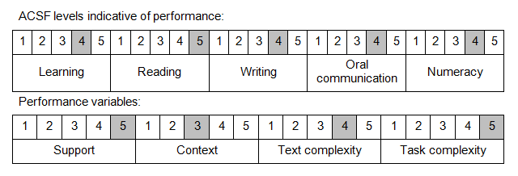

Further information on ACSF and the foundation skills underpinning this unit can be found in the Foundation Skills Guide on the GSA website.

Unit Mapping Information
This unit supersedes and is equivalent to NWP512B Implement and manage catchment management plan.

Links
Companion Volume implementation guides are found in VETNet - https://vetnet.education.gov.au/Pages/TrainingDocs.aspx?q=26336bc0-04e5-49d9-8c31-46c49b6a0037
Companion Volume implementation guides are found in VETNet - https://vetnet.education.gov.au/Pages/TrainingDocs.aspx?q=26336bc0-04e5-49d9-8c31-46c49b6a0037
Companion Volume implementation guides are found in VETNet - https://vetnet.education.gov.au/Pages/TrainingDocs.aspx?q=26336bc0-04e5-49d9-8c31-46c49b6a0037
Companion Volume implementation guides are found in VETNet - https://vetnet.education.gov.au/Pages/TrainingDocs.aspx?q=26336bc0-04e5-49d9-8c31-46c49b6a0037

