NWPIRR072 Implement and coordinate surface water management plan
Release: 1

NWPIRR072 Implement and coordinate surface water management plan

Modification History
Release | Comments
1 | This unit was released in NWP Water Training Package release 1.0 and meets the Standards for Training Packages.  This unit supersedes and is equivalent to NWP516B Implement and manage surface water management plan.  - Unit code updated  - Content and formatting updated to comply with the new standards  - All PC transitioned from passive to active voice  - Unit title changed to better reflect unit outcomes

Application
This unit describes the skills required for the implementation of the management plan for surface water to ensure environmental considerations are met and source of supply is maintained.
This unit applies to those working as managers in water organisations with responsibility for the management of surface water resources.
The skills and knowledge described in this unit must be applied within the legislative, regulatory and policy environment in which they are carried out. Organisational policies and procedures must be consulted and adhered to.
Those undertaking this unit would work autonomously, managing staff, while performing sophisticated tasks in a range of familiar contexts.
No licensing, legislative or certification requirements apply to unit at the time of publication.

Competency Field
Irrigation

Elements and Performance Criteria
ELEMENTS | PERFORMANCE CRITERIA
Elements describe the essential outcomes | Performance criteria describe the performance needed to demonstrate achievement of the element. Where bold italicised text is used, further information is detailed in the range of conditions section.
1. Implement and coordinate monitoring and testing program | 1.1 Confirm performance measures of the surface water management plan.  1.2 Design and implement monitoring and testing programs.  1.3 Coordinate activities relating to the surface water plan.  1.4 Interpret and record test results and education programs.  1.5 Identify and investigate current and/or potential problems and report results and recommendations.  1.6 Gather and evaluate historical surface water information.  1.7 Monitor water usage, water flow and water quality according to the plan.
2. Monitor and evaluate performance of surface water management plans | 2.1 Identify, investigate and report deviations of planned water usage and quality and management plan procedures.  2.2 Review objectives of the management and implementation plans.  2.3 Review parameters for water usage and quality.  2.4 Monitor and review environmental factors that impact on surface water.  2.5 Make recommendations for changes to plan objectives and procedures and usage and quality parameters.  2.6 Provide advice and guidance to water users and stakeholders.
3. Report on monitoring and implementation activities | 3.1 Identify and report deviations from the management plan.  3.2 Review and report objectives of the management and implementation plans.  3.3 Make recommendations for changes to plan objectives.

Foundation Skills
The foundation skills demands of this unit have been mapped for alignment with the Australian Core Skills Framework (ACSF). The following tables outline the performance levels indicated for successful attainment of the unit.
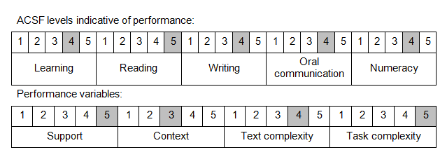

Further information on ACSF and the foundation skills underpinning this unit can be found in the Foundation Skills Guide on the GSA website.

Unit Mapping Information
This unit supersedes and is equivalent to NWP516B Implement and manage surface water management plan.

Links
Companion Volume implementation guides are found in VETNet - https://vetnet.education.gov.au/Pages/TrainingDocs.aspx?q=26336bc0-04e5-49d9-8c31-46c49b6a0037
Companion Volume implementation guides are found in VETNet - https://vetnet.education.gov.au/Pages/TrainingDocs.aspx?q=26336bc0-04e5-49d9-8c31-46c49b6a0037
Companion Volume implementation guides are found in VETNet - https://vetnet.education.gov.au/Pages/TrainingDocs.aspx?q=26336bc0-04e5-49d9-8c31-46c49b6a0037
Companion Volume implementation guides are found in VETNet - https://vetnet.education.gov.au/Pages/TrainingDocs.aspx?q=26336bc0-04e5-49d9-8c31-46c49b6a0037

