NWPIRR071 Implement and coordinate irrigation delivery systems
Release: 1

NWPIRR071 Implement and coordinate irrigation delivery systems

Modification History
Release | Comments
1 | This unit was released in NWP Water Training Package release 1.0 and meets the Standards for Training Packages.  This unit supersedes and is equivalent to NWP530B Implement and manage the operation and maintenance of irrigation delivery systems.  - Unit code updated  - Content and formatting updated to comply with the new standards  - All PC transitioned from passive to active voice  - Unit title changed to better reflect unit outcomes.  - PC 2.3 revised

Application
This unit describes the skills required to implement and manage the operation and maintenance of irrigation delivery systems, including system performance analysis, customer liaison and planning.

This unit applies to those working as managers in water organisations with responsibility for the implementation of irrigation system management plans.

The skills and knowledge described in this unit must be applied within the legislative, regulatory and policy environment in which they are carried out. Organisational policies and procedures must be consulted and adhered to.

Those undertaking this unit would work autonomously, managing staff, while performing sophisticated tasks in a range of familiar contexts.

No licensing, legislative or certification requirements apply to unit at the time of publication.

Competency Field
Irrigation

Elements and Performance Criteria
ELEMENTS | PERFORMANCE CRITERIA
Elements describe the essential outcomes | Performance criteria describe the performance needed to demonstrate achievement of the element. Where bold italicised text is used, further information is detailed in the range of conditions section.
1. Implement the irrigation system management plan | 1.1 Confirm performance measures for the irrigation system management plan.  1.2 Access and interpret historic system information to inform the implementation process.  1.3 Inform stakeholders about the system management plan.  1.4 Develop management plan components and activities for implementation.  1.5 Develop the implementation plan.  1.6 Determine responsibilities and timelines for the implementation activities.
2. Monitor and evaluate the operation and maintenance of the irrigation system | 2.1 Plan, perform and report on monitoring and testing procedures to identify deviations of planned water system quantity, quality, release and flow rates.  2.2 Evaluate delivery of water to customers (timeliness, volume and flow rates) and identify, investigate and report deviations from agreed service.  2.3 Evaluate maintenance budgets, activity programs and output target measures.  2.4 Identify, investigate and report deviations from targets.  2.5 Identify and document links between operational problems and maintenance activities.
3. Report on the implementation of the irrigation system management plan | 3.1 Identify, investigate and report deviations of planned water usage, quality and management plan procedures.  3.2 Review objectives of the management and implementation plans.  3.3 Make recommendations for changes to plan objectives and operational and maintenance procedures.

Foundation Skills
The foundation skills demands of this unit have been mapped for alignment with the Australian Core Skills Framework (ACSF). The following tables outline the performance levels indicated for successful attainment of the unit.

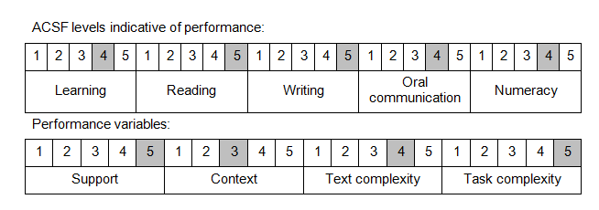

Further information on ACSF and the foundation skills underpinning this unit can be found in the Foundation Skills Guide on the GSA website.

Unit Mapping Information
This unit supersedes and is equivalent to NWP530B Implement and manage the operation and maintenance of irrigation delivery systems.

Links
GSA website - http://www.govskills.com.au
Implementation Guide - http://www.govskills.com.au/guides/water/implementation-guide
Knowledge Guide - http://www.govskills.com.au/guides/water/knowledge-guide
Foundation Skills Guide - http://www.govskills.com.au/guides/water/foundation-skills-guide

