NWPIRR061 Develop and review groundwater management plan
Release: 1

NWPIRR061 Develop and review groundwater management plan

Modification History
Release | Comments
1 | This unit was released in NWP Water Training Package release 1.0 and meets the Standards for Training Packages.  This unit supersedes and is equivalent to NWP515B Develop and review groundwater management plan.  - Unit code updated  - Content and formatting updated to comply with the new standards  - All PC transitioned from passive to active voice

Application
This unit describes the skills required for the management of groundwater as a resource to be used for water supply.

This unit applies to those working as managers in water organisations with responsibility for the development and review of groundwater resources.

The skills and knowledge described in this unit must be applied within the legislative, regulatory and policy environment in which they are carried out. Organisational policies and procedures must be consulted and adhered to.

Those undertaking this unit would work autonomously, managing staff, while performing sophisticated tasks in a range of familiar contexts.

No licensing, legislative or certification requirements apply to unit at the time of publication.

Competency Field
Irrigation

Elements and Performance Criteria
ELEMENTS | PERFORMANCE CRITERIA
Elements describe the essential outcomes | Performance criteria describe the performance needed to demonstrate achievement of the element. Where bold italicised text is used, further information is detailed in the range of conditions section.
1. Prepare for groundwater management | 1.1 Gather historical groundwater information and evaluate as input to the planning process.  1.2 Identify, interpret and assess water quality and quantity requirements.  1.3 Identify and interpret environmental and development factors that impact on groundwater.
2. Develop the groundwater management plan | 2.1 Identify and interpret groundwater management requirements.  2.2 Identify, interpret and validate stakeholder requirements that impact on groundwater.  2.3 Develop a groundwater management plan.  2.4 Identify, investigate and report breaches of usage provisions and changes to quality parameters.
3. Review and refine the groundwater management plan | 3.1 Assess data from the ongoing implementation and monitoring of the groundwater management plan and use to inform the review of the plan.  3.2 Review objectives of the management and implementation plans.  3.3 Make recommendations for changes to objectives and implementation procedures.  3.4 Provide advice and guidance to groundwater users and other stakeholders.

Foundation Skills
The foundation skills demands of this unit have been mapped for alignment with the Australian Core Skills Framework (ACSF). The following tables outline the performance levels indicated for successful attainment of the unit.

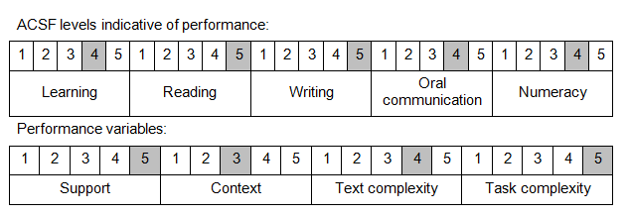

Further information on ACSF and the foundation skills underpinning this unit can be found in the Foundation Skills Guide on the GSA website.

Unit Mapping Information
This unit supersedes and is equivalent to NWP515B Develop and review groundwater management plan.

Links
GSA website - http://www.govskills.com.au
Implementation Guide - http://www.govskills.com.au/guides/water/implementation-guide
Knowledge Guide - http://www.govskills.com.au/guides/water/knowledge-guide
Foundation Skills Guide - http://www.govskills.com.au/guides/water/foundation-skills-guide

