NWPIRR042 Monitor and schedule water deliveries
Release: 1

NWPIRR042 Monitor and schedule water deliveries

Modification History
Release | Comments
1 | This unit was released in NWP Water Training Package release 1.0 and meets the Standards for Training Packages.  This unit supersedes and is equivalent to NWP316B Monitor and schedule water deliveries.  - Unit code updated  - Content and formatting updated to comply with the new standards  - All PC transitioned from passive to active voice

Application
This unit of competency describes the skills required to schedule water deliveries for irrigation and/or domestic and stock supply systems, including monitoring flows, analysing data, coordinating hydraulic processes and compiling operational reports.
This unit applies to those working as field staff and operators with a specific responsibility for ensuring that water deliveries meet varying customer requirements.
The skills and knowledge described in this unit must be applied within the legislative, regulatory and policy environment in which they are carried out. Organisational policies and procedures must be consulted and adhered to, particularly those related to WHS.
Those undertaking this unit would work under indirect supervision, while performing routine tasks ensuring minimum damage to the environment, in a familiar.
No licensing, legislative or certification requirements apply to unit at the time of publication.

Competency Field
Irrigation

Elements and Performance Criteria
ELEMENTS | PERFORMANCE CRITERIA
Elements describe the essential outcomes | Performance criteria describe the performance needed to demonstrate achievement of the element. Where bold italicised text is used, further information is detailed in the range of conditions section.
1. Schedule water deliveries | 1.1 Identify and record customer water orders.  1.2 Analyse water orders to determine water delivery and flow rate requirements.  1.3 Schedule water deliveries to meet flow rate requirements and organisational standards for channel balance and capacity restraints.
2. Monitor water delivery | 2.1 Monitor channel flow rate, regulation and delivery according to customer requirements.  2.2 Maintain delivery performance records.  2.3 Analyse system performance using system data and records to determine actual and planned performance.
3. Coordinate and control water delivery | 3.1 Calculate system adjustments according to demand and organisational requirements.  3.2 Coordinate flow regulation, channel levels, security of flow devices and settings according to demand and organisational requirements.
4. Compile records of water delivery | 4.1 Compile reports from systems performance data.  4.2 Maintain appropriate measurement and delivery records.

Foundation Skills
The foundation skills demands of this unit have been mapped for alignment with the Australian Core Skills Framework (ACSF). The following tables outline the performance levels indicated for successful attainment of the unit.

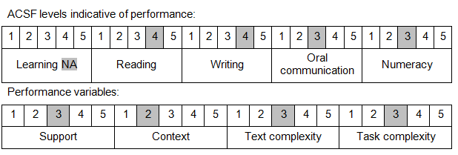

Further information on ACSF and the foundation skills underpinning this unit can be found in the Foundation Skills Guide on the GSA website.

Unit Mapping Information
This unit supersedes and is equivalent to NWP316B Monitor and schedule water deliveries.

Links
Companion Volume implementation guides are found in VETNet - https://vetnet.gov.au/Pages/TrainingDocs.aspx?q=26336bc0-04e5-49d9-8c31-46c49b6a0037
Companion Volume implementation guides are found in VETNet - https://vetnet.gov.au/Pages/TrainingDocs.aspx?q=26336bc0-04e5-49d9-8c31-46c49b6a0037
Companion Volume implementation guides are found in VETNet - https://vetnet.gov.au/Pages/TrainingDocs.aspx?q=26336bc0-04e5-49d9-8c31-46c49b6a0037
Companion Volume implementation guides are found in VETNet - https://vetnet.gov.au/Pages/TrainingDocs.aspx?q=26336bc0-04e5-49d9-8c31-46c49b6a0037

