NWPIRR041 Identify and apply water entitlements and delivery processes
Release: 1

NWPIRR041 Identify and apply water entitlements and delivery processes

Modification History
Release | Comments
1 | This unit was released in NWP Water Training Package release 1.0 and meets the Standards for Training Packages.  This unit supersedes and is equivalent to NWP239B Identify and apply water entitlements and delivery processes.  - Unit code updated  - Content and formatting updated to comply with the new standards  - All PC transitioned from passive to active voice

Application
This unit describes the skills required to identify and apply irrigation, and stock and domestic supply systems, measure water and report water usage.
This unit applies to those working as field operators involved with the operation of raw water systems, including the identification of water entitlements and delivery processes.
The skills and knowledge described in this unit must be applied within the legislative, regulatory and policy environment in which they are carried out. Organisational policies and procedures must be consulted and adhered to, particularly those related to water acts, water entitlement, identification and notification of breaches and property water allocation.
Those undertaking this unit would work independently or in a team under direct supervision, using own familiar resources as required, while performing routine tasks in range of familiar contexts.
No licensing, legislative or certification requirements apply to unit at the time of publication.

Competency Field
Irrigation

Elements and Performance Criteria
ELEMENTS | PERFORMANCE CRITERIA
Elements describe the essential outcomes | Performance criteria describe the performance needed to demonstrate achievement of the element. Where bold italicised text is used, further information is detailed in the range of conditions section.
1. Identify and apply water entitlements | 1.1 Apply principles of allocation or sale of water to properties and landholders.  1.2 Apply changes to entitlement or allocation to properties and between properties to workplace practices.  1.3 Apply relevant sections of legislation relating to water distribution and delivery to workplace practices, including breach notification.  1.4 Identify relevant water products and services offered to customers, and customer contracts.
2. Identify and apply principles of water supply networks and distribution systems | 2.1 Identify relevant type and structure of water supply networks and their interaction where relevant.  2.2 Identify design and operation of relevant components of water distribution system.  2.3 Identify and monitor principles of water flow and factors affecting water flow.  2.4 Identify and apply basic principles of regulating water efficiently through the water supply system.
3. Record and monitor water use | 3.1 Monitor, report and measure water flows and volumes.  3.2 Identify and monitor balance of water entitlements.

Foundation Skills
The foundation skills demands of this unit have been mapped for alignment with the Australian Core Skills Framework (ACSF). The following tables outline the performance levels indicated for successful attainment of the unit.

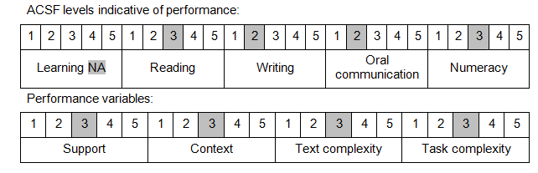

Further information on ACSF and the foundation skills underpinning this unit can be found in the Foundation Skills Guide on the GSA website.

Unit Mapping Information
This unit supersedes and is equivalent to NWP239B Identify and apply water entitlements and delivery processes.

Links
Companion Volume implementation guides are found in VETNet - https://vetnet.education.gov.au/Pages/TrainingDocs.aspx?q=26336bc0-04e5-49d9-8c31-46c49b6a0037
Companion Volume implementation guides are found in VETNet - https://vetnet.education.gov.au/Pages/TrainingDocs.aspx?q=26336bc0-04e5-49d9-8c31-46c49b6a0037
Companion Volume implementation guides are found in VETNet - https://vetnet.education.gov.au/Pages/TrainingDocs.aspx?q=26336bc0-04e5-49d9-8c31-46c49b6a0037
Companion Volume implementation guides are found in VETNet - https://vetnet.education.gov.au/Pages/TrainingDocs.aspx?q=26336bc0-04e5-49d9-8c31-46c49b6a0037

