NWPIRR035 Coordinate and monitor the operation of drainage systems
Release: 1

NWPIRR035 Coordinate and monitor the operation of drainage systems

Modification History
Release | Comments
1 | This unit was released in NWP Water Training Package release 1.0 and meets the Standards for Training Packages.  This unit supersedes and is equivalent to NWP427B Coordinate and monitor the operation of drainage systems.  - Unit code updated  - Content and formatting updated to comply with the new standards  - All PC transitioned from passive to active voice  - PC 1.2, 1.3 and 1.4 merged

Application
This unit describes the skills required to coordinate and monitor drainage systems to ensure compliance with the drainage systems management plan, including system performance, maintenance planning and customer liaison.
This unit applies to those working as field or operational staff with a specific responsibility for ensuring that the operation of drainage systems complies with organisational and statutory requirements.
The skills and knowledge described in this unit must be applied within the legislative, regulatory and policy environment in which they are carried out. Organisational policies and procedures must be consulted and adhered to, particularly those related to WHS.
Those undertaking this unit would work independently or in a team, while performing complex tasks ensuring minimum damage to the environment, in a familiar context. However, the level of responsibility may vary according to the size, scope, location, and technical complexity of process.
No licensing, legislative or certification requirements apply to unit at the time of publication.

Competency Field
Irrigation

Elements and Performance Criteria
ELEMENTS | PERFORMANCE CRITERIA
Elements describe the essential outcomes | Performance criteria describe the performance needed to demonstrate achievement of the element. Where bold italicised text is used, further information is detailed in the range of conditions section.
1. Confirm performance measures in the drainage system management plan | 1.1 Confirm data gathering requirements specified in the drainage system management plan.  1.2 Identify, analyse and address issues, environmental factors and stakeholder requirements that impact on drainage systems.  1.3 Access historic system information and apply as required.
2. Monitor and coordinate processes and resource targets | 2.1 Select, fit and use equipment, including personal protective equipment.  2.2 Conduct system performance monitoring and testing according to the drainage management plan.  2.3 Analyse and report test results.  2.4 Identify current and potential problems, conduct investigations and report results and recommendations.  2.5 Identify breaches of the drainage management plan, conduct investigations and report results and recommendations.  2.6 Evaluate maintenance budgets, activity programs and output target measures and identify, analyse and address any deviations from targets.  2.7 Identify and record links between operational problems and maintenance activities.
3. Report outcomes of coordination and monitoring | 3.1 Analyse, record and report coordination and monitoring data.  3.2 Identify and report current and potential problems.  3.3 Make recommendations to improve system performance and/or customer service standards.

Foundation Skills
The foundation skills demands of this unit have been mapped for alignment with the Australian Core Skills Framework (ACSF). The following tables outline the performance levels indicated for successful attainment of the unit.

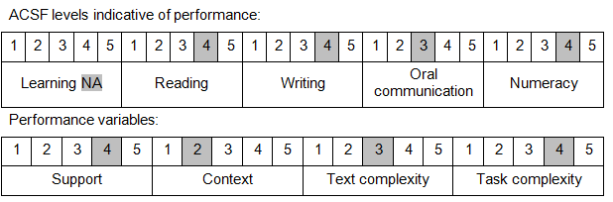

Further information on ACSF and the foundation skills underpinning this unit can be found in the Foundation Skills Guide on the GSA website.

Unit Mapping Information
This unit supersedes and is equivalent to NWP427B Coordinate and monitor the operation of drainage systems.

Links
Companion Volume implementation guides are found in VETNet - https://vetnet.gov.au/Pages/TrainingDocs.aspx?q=26336bc0-04e5-49d9-8c31-46c49b6a0037
Companion Volume implementation guides are found in VETNet - https://vetnet.gov.au/Pages/TrainingDocs.aspx?q=26336bc0-04e5-49d9-8c31-46c49b6a0037
Companion Volume implementation guides are found in VETNet - https://vetnet.gov.au/Pages/TrainingDocs.aspx?q=26336bc0-04e5-49d9-8c31-46c49b6a0037
Companion Volume implementation guides are found in VETNet - https://vetnet.gov.au/Pages/TrainingDocs.aspx?q=26336bc0-04e5-49d9-8c31-46c49b6a0037

