NWPIRR033 Coordinate and monitor the operation of irrigation delivery systems
Release: 1

NWPIRR033 Coordinate and monitor the operation of irrigation delivery systems

Modification History
Release | Comments
1 | This unit was released in NWP Water Training Package release 1.0 and meets the Standards for Training Packages.  This unit supersedes and is equivalent to NWP425B Coordinate and monitor the operation of irrigation delivery systems.  - Unit code updated  - Content and formatting updated to comply with the new standards  - All PC transitioned from passive to active voice  - PC 2.1 removed  - PC 2.2 reworded  - PC 2.4 revised

Application
This unit describes the skills required to coordinate and monitor irrigation delivery systems to meet performance standards and including system maintenance and customer liaison.
This unit applies to those working as field and operational staff with a specific responsibility for ensuring that the operation of irrigation systems complies with organisational and statutory requirements.
The skills and knowledge described in this unit must be applied within the legislative, regulatory and policy environment in which they are carried out. Organisational policies and procedures must be consulted and adhered to.
Those undertaking this unit would work independently or in a team, while performing complex tasks ensuring minimum damage to the environment in a familiar context. However, the level of responsibility may vary according to the size, scope, location, and technical complexity of process.
No licensing, legislative or certification requirements apply to unit at the time of publication.

Competency Field
Irrigation

Elements and Performance Criteria
ELEMENTS | PERFORMANCE CRITERIA
Elements describe the essential outcomes | Performance criteria describe the performance needed to demonstrate achievement of the element. Where bold italicised text is used, further information is detailed in the range of conditions section.
1. Confirm performance measures in irrigation system’s management plan | 1.1 Identify customer requirements for irrigated culture.  1.2 Identify environmental factors that impact on the irrigation system.  1.3 Consult historic system information and stakeholders as appropriate.  1.4 Confirm performance requirements for an irrigation system management plan.
2. Monitor and coordinate processes and resource targets | 2.1 Monitor and test programs and identify, investigate and report any deviations from water quantity, quality, release or flow.  2.2 Evaluate the duration, volume and flow rates of water deliveries and identify, investigate and report deviations from agreed service levels.  2.3 Evaluate maintenance activities and report deviations from targets.  2.4 Identify and record links between operational problems and maintenance activities.
3. Report outcomes of coordination and monitoring | 3.1 Analyse, record and report coordination and monitoring data.  3.2 Identify and report current and potential problems.  3.3 Make recommendations for improvements in system performance and/or customer service.

Foundation Skills
The foundation skills demands of this unit have been mapped for alignment with the Australian Core Skills Framework (ACSF). The following tables outline the performance levels indicated for successful attainment of the unit.
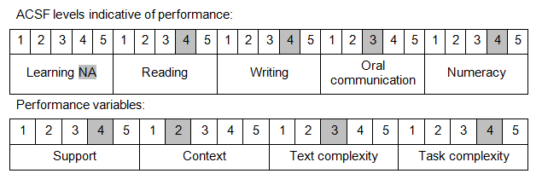

Further information on ACSF and the foundation skills underpinning this unit can be found in the Foundation Skills Guide on the GSA website.

Unit Mapping Information
This unit supersedes and is equivalent to NWP425B Coordinate and monitor the operation of irrigation delivery systems.

Links
Companion Volume implementation guides are found in VETNet - https://vetnet.gov.au/Pages/TrainingDocs.aspx?q=26336bc0-04e5-49d9-8c31-46c49b6a0037
Companion Volume implementation guides are found in VETNet - https://vetnet.gov.au/Pages/TrainingDocs.aspx?q=26336bc0-04e5-49d9-8c31-46c49b6a0037
Companion Volume implementation guides are found in VETNet - https://vetnet.gov.au/Pages/TrainingDocs.aspx?q=26336bc0-04e5-49d9-8c31-46c49b6a0037
Companion Volume implementation guides are found in VETNet - https://vetnet.gov.au/Pages/TrainingDocs.aspx?q=26336bc0-04e5-49d9-8c31-46c49b6a0037

