NWPIRR032 Monitor and control rural water distribution operations
Release: 1

NWPIRR032 Monitor and control rural water distribution operations

Modification History
Release | Comments
1 | This unit was released in NWP Water Training Package release 1.0 and meets the Standards for Training Packages.  This unit supersedes and is equivalent to NWP333B Monitor and control rural water distribution operations.  - Unit code updated  - Content and formatting updated to comply with the new standards  - All PC transitioned from passive to active voice

Application
This unit describes the skills required to monitor, control and coordinate rural water flow, scheduling and delivery and to report on rural water distribution, including irrigation, domestic and stock supply systems. The ability to identify faults, gather data, interpret technical information and operate technical equipment is essential to performance.
This unit applies to those working as field staff with a responsibility for monitoring and operating rural water distribution systems.
The skills and knowledge described in this unit must be applied within the legislative, regulatory and policy environment in which they are carried out. Organisational policies and procedures must be consulted and adhered to, particularly those related to WHS.
Those undertaking this unit would work under indirect supervision, while performing routine tasks ensuring minimum damage to the environment, in a familiar context.
No licensing, legislative or certification requirements apply to unit at the time of publication.

Competency Field
Irrigation

Elements and Performance Criteria
ELEMENTS | PERFORMANCE CRITERIA
Elements describe the essential outcomes | Performance criteria describe the performance needed to demonstrate achievement of the element. Where bold italicised text is used, further information is detailed in the range of conditions section.
1. Monitor water delivery system | 1.1 Perform routine inspections of channel flow rates, regulations and delivery according to demand and organisational and statutory requirements.  1.2 Gather and record system performance data.  1.3 Identify and correct system faults according to plans and service standards.  1.4 Select, fit and use required safety equipment, including personal protective equipment.
2. Control processes | 2.1 Determine and apply system adjustments required to meet demands.  2.2 Initiate and coordinate system adjustments required for delivery or channel flow rates.  2.3 Integrate processes to improve the delivery network performance.
3. Analyse data and compile reports | 3.1 Conduct analysis of actual performance against planned system performance using system data and records.  3.2 Compile reports from system performance data.

Foundation Skills
The foundation skills demands of this unit have been mapped for alignment with the Australian Core Skills Framework (ACSF). The following tables outline the performance levels indicated for successful attainment of the unit.

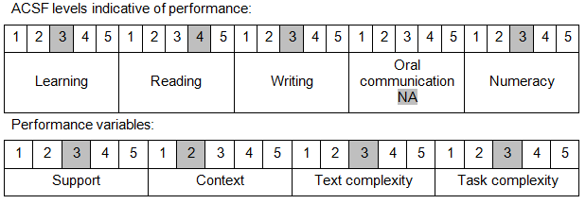

Further information on ACSF and the foundation skills underpinning this unit can be found in the Foundation Skills Guide on the GSA website.

Unit Mapping Information
This unit supersedes and is equivalent to NWP333B Monitor and control rural water distribution operations.

Links
Companion Volume implementation guides are found in VETNet - https://vetnet.education.gov.au/Pages/TrainingDocs.aspx?q=26336bc0-04e5-49d9-8c31-46c49b6a0037
Companion Volume implementation guides are found in VETNet - https://vetnet.education.gov.au/Pages/TrainingDocs.aspx?q=26336bc0-04e5-49d9-8c31-46c49b6a0037
Companion Volume implementation guides are found in VETNet - https://vetnet.education.gov.au/Pages/TrainingDocs.aspx?q=26336bc0-04e5-49d9-8c31-46c49b6a0037
Companion Volume implementation guides are found in VETNet - https://vetnet.education.gov.au/Pages/TrainingDocs.aspx?q=26336bc0-04e5-49d9-8c31-46c49b6a0037

