NWPIRR031 Monitor and control drainage operations
Release: 1

NWPIRR031 Monitor and control drainage operations

Modification History
Release | Comments
1 | This unit was released in NWP Water Training Package release 1.0 and meets the Standards for Training Packages.  This unit supersedes and is equivalent to NWP332B Monitor and control drainage operations.  - Unit code updated  - Content and formatting updated to comply with the new standards  - All PC transitioned from passive to active voice  - Element 2 reworded and all PC revised  - Elements 3 and 4 merged  - PC 1.3, 1.4 and 1.5 removed  - One new PC added to Element 1

Application
This unit describes the skills required to monitor, operate and control drainage systems. The ability to identify faults, gather data, interpret technical information and operate technical equipment is essential to performance.
This unit applies to those working as field staff with a responsibility for inspecting and reporting faults in drainage systems and for operating, integrating and regulating drainage system processes.
The skills and knowledge described in this unit must be applied within the legislative, regulatory and policy environment in which they are carried out. Organisational policies and procedures must be consulted and adhered to, particularly those related to WHS.
Those undertaking this unit would work under indirect supervision, while performing routine tasks ensuring minimum damage to the environment, in a familiar context.
No licensing, legislative or certification requirements apply to unit at the time of publication.

Competency Field
Irrigation

Elements and Performance Criteria
ELEMENTS | PERFORMANCE CRITERIA
Elements describe the essential outcomes | Performance criteria describe the performance needed to demonstrate achievement of the element. Where bold italicised text is used, further information is detailed in the range of conditions section.
1. Inspect drainage systems | 1.1 Schedule and conduct routine inspections of drainage systems.  1.2 Monitor faults and take remedial action.  1.3 Collect and report data on drainage system performance and usage.
2. Monitor flows | 2.1 Monitor flows entering drains.  2.2 Monitor flows in drains to ensure correct drain operation.  2.3 Complete remedial action.
3. Control and operate processes | 3.1 Control processes to maintain parameters of operation.  3.2 Identify, address and report problems and operational conditions of the drainage network.  3.3 Integrate processes to improve drainage network performance.  3.4 Compile process records.

Foundation Skills
The foundation skills demands of this unit have been mapped for alignment with the Australian Core Skills Framework (ACSF). The following tables outline the performance levels indicated for successful attainment of the unit.

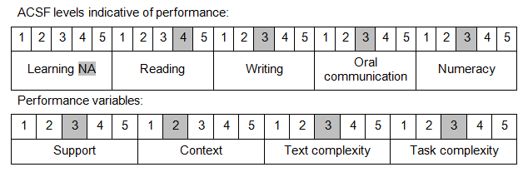

Further information on ACSF and the foundation skills underpinning this unit can be found in the Foundation Skills Guide on the GSA website.

Unit Mapping Information
This unit supersedes and is equivalent to NWP332B Monitor and control drainage operations.

Links
Companion Volume implementation guides are found in VETNet - https://vetnet.education.gov.au/Pages/TrainingDocs.aspx?q=26336bc0-04e5-49d9-8c31-46c49b6a0037
Companion Volume implementation guides are found in VETNet - https://vetnet.education.gov.au/Pages/TrainingDocs.aspx?q=26336bc0-04e5-49d9-8c31-46c49b6a0037
Companion Volume implementation guides are found in VETNet - https://vetnet.education.gov.au/Pages/TrainingDocs.aspx?q=26336bc0-04e5-49d9-8c31-46c49b6a0037
Companion Volume implementation guides are found in VETNet - https://vetnet.education.gov.au/Pages/TrainingDocs.aspx?q=26336bc0-04e5-49d9-8c31-46c49b6a0037

