NWPIRR024 Monitor and conduct maintenance on flow control and metering devices
Release: 1

NWPIRR024 Monitor and conduct maintenance on flow control and metering devices

Modification History
Release | Comments
1 | This unit was released in NWP Water Training Package release 1.0 and meets the Standards for Training Packages.  This unit supersedes and is equivalent to NWP305B Monitor and conduct maintenance of complex flow-control and metering devices.  - Unit code updated  - Content and formatting updated to comply with the new standards  - Unit title changed to better reflect unit outcomes  - All PC transitioned from passive to active voice  - One new PC added to Element 2  - All PC in Element reordered  - PC 4.3 removed

Application
This unit describes the skills required to monitor the operation of flow control. This includes measuring and regulating devices, controlling water supply source systems and/or distribution systems.
This unit applies to those working as field staff with a responsibility for monitoring the operation of flow control, measuring and regulating devices, conducting maintenance and ensuring that problems and anomalies are rectified by specialist technicians.
The skills and knowledge described in this unit must be applied within the legislative, regulatory and policy environment in which they are carried out. Organisational policies and procedures must be consulted and adhered to, particularly those related to WHS and manufacturer specifications.
Those undertaking this unit would work under indirect supervision, performing routine tasks ensuring minimum damage to the environment, in a familiar context.
No licensing, legislative or certification requirements apply to unit at the time of publication.

Competency Field
Irrigation

Elements and Performance Criteria
ELEMENTS | PERFORMANCE CRITERIA
Elements describe the essential outcomes | Performance criteria describe the performance needed to demonstrate achievement of the element. Where bold italicised text is used, further information is detailed in the range of conditions section.
1. Plan and prepare for work | 1.1 Interpret work requirements for monitoring flow control and metering devices from plans, drawing specifications and instructions.  1.2 Select and check equipment and tools to meet the safety requirements of the task and site.  1.3 Select, fit and use required safety equipment, including personal protective equipment.
2. Monitor device and equipment performance | 2.1 Identify devices and equipment.  2.2 Check and interpret information and specifications on devices and equipment performance.  2.3 Report on devices and equipment performance.
3. Conduct minor maintenance on devices and equipment | 3.1 Undertake routine maintenance tasks for complex devices.  3.2 Secure devices and equipment.  3.3 Identify and report problems and anomalies for correction.
4. Monitor system performance | 4.1 Schedule and monitor routine inspections of system and networks.  4.2 Collect, analyse and report data on system performance and usage.
5. Compile process records and reports | 5.1 Identify process faults and monitor the operational condition of the system and network.  5.2 Report on adjustment requirements and condition of the system.

Foundation Skills
The foundation skills demands of this unit have been mapped for alignment with the Australian Core Skills Framework (ACSF). The following tables outline the performance levels indicated for successful attainment of the unit.
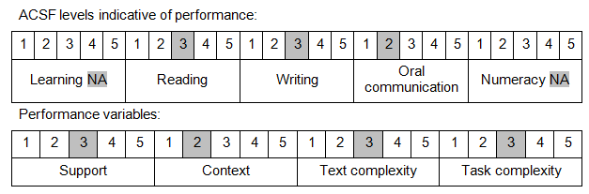

Further information on ACSF and the foundation skills underpinning this unit can be found in the Foundation Skills Guide on the GSA website.

Unit Mapping Information
This unit supersedes and is equivalent to NWP305B Monitor and conduct maintenance of complex flow-control and metering devices.

Links
Companion Volume implementation guides are found in VETNet - https://vetnet.gov.au/Pages/TrainingDocs.aspx?q=26336bc0-04e5-49d9-8c31-46c49b6a0037
Companion Volume implementation guides are found in VETNet - https://vetnet.gov.au/Pages/TrainingDocs.aspx?q=26336bc0-04e5-49d9-8c31-46c49b6a0037
Companion Volume implementation guides are found in VETNet - https://vetnet.gov.au/Pages/TrainingDocs.aspx?q=26336bc0-04e5-49d9-8c31-46c49b6a0037
Companion Volume implementation guides are found in VETNet - https://vetnet.gov.au/Pages/TrainingDocs.aspx?q=26336bc0-04e5-49d9-8c31-46c49b6a0037

