NWPIRR023 Detect and rectify faults with automated channel regulators
Release: 1

NWPIRR023 Detect and rectify faults with automated channel regulators

Modification History
Release | Comments
1 | This unit was released in NWP Water Training Package release 1.0 and meets the Standards for Training Packages.

Application
This unit describes the skills required to determine problems with the operation of automated water regulating devices in irrigation and stock and domestic supply systems. This includes collecting data, finding and fixing problems and compiling associated operational reports.
This unit applies to those working as part of an irrigation delivery team with specific duties to maintain and rectify faults in automated regulating devices.
The skills and knowledge described in this unit must be applied within the legislative, regulatory and policy environment in which they are carried out. Organisational policies and procedures must be consulted and adhered to.
Those undertaking this unit would work independently under indirect supervision performing routine tasks in a familiar context.
No licensing, legislative or certification requirements apply to unit at the time of publication.

Competency Field
Irrigation

Elements and Performance Criteria
ELEMENTS | PERFORMANCE CRITERIA
Elements describe the essential outcomes | Performance criteria describe the performance needed to demonstrate achievement of the element. Where bold italicised text is used, further information is detailed in the range of conditions section.
1. Plan and prepare work | 1.1 Identify and access fault records from computerised or manual systems.  1.2 Interpret and categorise fault information.  1.3 Schedule and prioritise actions for repair of faults.
2. Rectify the faults of regulating devices | 2.1 Use the software program to assist in rectifying faults.  2.2 Complete on-site inspection of faulty regulating device and determine problems.  2.3 Undertake regulator repairs to rectify faults.  2.4 Check the operating conditions of the regulating device meet manufacturer specifications.
3. Finalise work | 3.1 Notify operational team of the state of repair work and operating conditions of regulating device.  3.2 Complete and file reports of repair.  3.3 Liaise with external contractors and operational team.

Foundation Skills
The foundation skills demands of this unit have been mapped for alignment with the Australian Core Skills Framework (ACSF). The following tables outline the performance levels indicated for successful attainment of the unit.

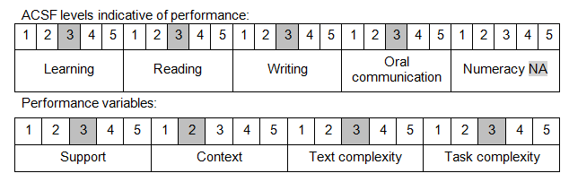

Further information on ACSF and the foundation skills underpinning this unit can be found in the Foundation Skills Guide on the GSA website.

Range of Conditions
Fault types include: | - computerised  - mechanical  - electrical

Unit Mapping Information
No equivalent unit.

Links
Companion Volume implementation guides are found in VETNet - https://vetnet.education.gov.au/Pages/TrainingDocs.aspx?q=26336bc0-04e5-49d9-8c31-46c49b6a0037
Companion Volume implementation guides are found in VETNet - https://vetnet.education.gov.au/Pages/TrainingDocs.aspx?q=26336bc0-04e5-49d9-8c31-46c49b6a0037
Companion Volume implementation guides are found in VETNet - https://vetnet.education.gov.au/Pages/TrainingDocs.aspx?q=26336bc0-04e5-49d9-8c31-46c49b6a0037
Companion Volume implementation guides are found in VETNet - https://vetnet.education.gov.au/Pages/TrainingDocs.aspx?q=26336bc0-04e5-49d9-8c31-46c49b6a0037

