NWPIRR022 Maintain meters for rural water supplies
Release: 1

NWPIRR022 Maintain meters for rural water supplies

Modification History
Release | Comments
1 | This unit was released in NWP Water Training Package release 1.0 and meets the Standards for Training Packages.  This unit supersedes and is equivalent to NWP304A Maintain meter for non-potable, non-urban water supplies.  - Unit code updated  - Content and formatting updated to comply with the new standards  - All PC transitioned from passive to active voice  - Unit title changed to better reflect unit outcomes  - PC 4.3 removed  - PC 1.3 and 1.4 merged  - PC 2.1, 2.3, 2.4 and 2.5 merged and revised

Application
This unit describes the skills required to maintain the operational integrity of already installed meters, metering systems and their components. This unit covers corrective, predictive and preventative maintenance.
This unit applies to those working in the water industry as field or operational staff maintaining meters for rural water supply.
The skills and knowledge described in this unit must be applied within the legislative, regulatory and policy environment in which they are carried out. Organisational policies and procedures must be consulted and adhered to.
Those undertaking this unit would work under independently under direct supervision, while performing routine tasks in familiar context.
No licensing, legislative or certification requirements apply to unit at the time of publication.

Competency Field
Irrigation

Elements and Performance Criteria
ELEMENTS | PERFORMANCE CRITERIA
Elements describe the essential outcomes | Performance criteria describe the performance needed to demonstrate achievement of the element. Where bold italicised text is used, further information is detailed in the range of conditions section.
1. Confirm meter type and location within asset management system | 1.1 Obtain organisational maintenance plan and manufacturer guidelines.  1.2 Locate meter emplacement on a map, or by GPS, or according to organisational procedures.  1.3 Confirm that meter type and number match maintenance plan or manufacturer guidelines.
2. Check condition of meters and metering system | 2.1 Check components and identify faults using an asset condition checklist.  2.2 Establish maintenance requirements.
3. Maintain meter and meter facilities | 3.1 Repair or replace faulty components.  3.2 Identify faults which need to be rectified by a third party.
4. Test and recommission | 4.1 Ensure meter complies with standards.  4.2 Perform on-site re-test of meter.  4.3 Record faults and meter performance, maintenance and repairs.

Foundation Skills
The foundation skills demands of this unit have been mapped for alignment with the Australian Core Skills Framework (ACSF). The following tables outline the performance levels indicated for successful attainment of the unit
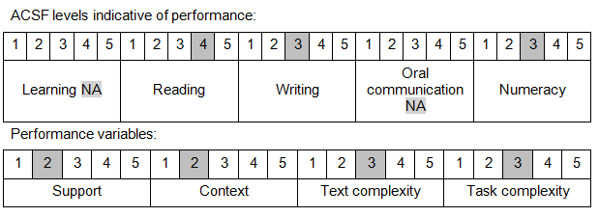
Further information on ACSF and the foundation skills underpinning this unit can be found in the Foundation Skills Guide on the GSA website.

Unit Mapping Information
This unit supersedes and is equivalent to NWP304A Maintain meter for non-potable, non-urban water supplies.

Links
Companion Volume implementation guides are found in VETNet - https://vetnet.gov.au/Pages/TrainingDocs.aspx?q=26336bc0-04e5-49d9-8c31-46c49b6a0037
Companion Volume implementation guides are found in VETNet - https://vetnet.gov.au/Pages/TrainingDocs.aspx?q=26336bc0-04e5-49d9-8c31-46c49b6a0037
Companion Volume implementation guides are found in VETNet - https://vetnet.gov.au/Pages/TrainingDocs.aspx?q=26336bc0-04e5-49d9-8c31-46c49b6a0037
Companion Volume implementation guides are found in VETNet - https://vetnet.gov.au/Pages/TrainingDocs.aspx?q=26336bc0-04e5-49d9-8c31-46c49b6a0037

