NWPIRR021 Maintain and repair irrigation channels and drains
Release: 1

NWPIRR021 Maintain and repair irrigation channels and drains

Modification History
Release | Comments
1 | This unit was released in NWP Water Training Package release 1.0 and meets the Standards for Training Packages.  This unit supersedes and is equivalent to NWP230B Maintain and repair irrigation channels and drains.  - Unit code updated  - Content and formatting updated to comply with the new standards  - All PC transitioned from passive to active voice  - One new PC added to Element 1

Application
This unit describes the skills required to maintain and repair irrigation or stock and domestic supply channels and drains.
This unit applies to those working as field and operational staff with responsibility for carrying out planned and emergency maintenance and repair work on raw water delivery systems.
The skills and knowledge described in this unit must be applied within the legislative, regulatory and policy environment in which they are carried out. Organisational policies and procedures must be consulted and adhered to, particularly those related to environmental requirements and WHS.
Those undertaking this unit would work independently or in a team under direct supervision using own familiar resources as required. They will perform routine tasks, ensuring minimum damage to the environment, in a range of familiar contexts.
No licensing, legislative or certification requirements apply to unit at the time of publication.

Competency Field
Irrigation

Elements and Performance Criteria
ELEMENTS | PERFORMANCE CRITERIA
Elements describe the essential outcomes | Performance criteria describe the performance needed to demonstrate achievement of the element. Where bold italicised text is used, further information is detailed in the range of conditions section.
1. Plan and prepare work site | 1.1 Determine work requirements from plans, drawings, specifications or instructions.  1.2 Notify relevant stakeholders and customers of maintenance work.  1.3 Make appropriate drainage, de-watering and inflow diversion arrangements.  1.4 Select and check equipment and work methods to meet safety requirements of task and site.
2. Maintain irrigation channels, drains and associated fittings | 2.1 Conduct routine inspections of designated work areas according to maintenance schedules.  2.2 Identify system faults and apply corrective action according to structure type, location, specification.  2.3 Identify, select, place and join components and associated fittings.  2.4 Construct components on-site.  2.5 Repair earthworks and embankments.
3. Check work and restore work site | 3.1 Check repaired or replaced components to ensure that specifications have been met.  3.2 Backfill, compact, restore work site and refill the system.
4. Finalise work | 4.1 Check, maintain and store equipment, tools and materials.  4.2 Complete and process workplace records.

Foundation Skills
The foundation skills demands of this unit have been mapped for alignment with the Australian Core Skills Framework (ACSF). The following tables outline the performance levels indicated for successful attainment of the unit.

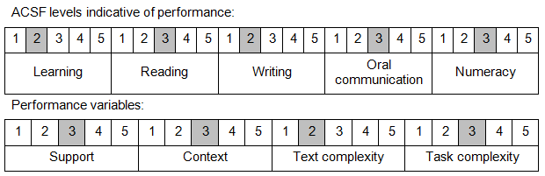

Further information on ACSF and the foundation skills underpinning this unit can be found in the Foundation Skills Guide on the GSA website

Unit Mapping Information
This unit supersedes and is equivalent to NWP230B Maintain and repair irrigation channels and drains.

Links
Companion Volume implementation guides are found in VETNet - https://vetnet.education.gov.au/Pages/TrainingDocs.aspx?q=26336bc0-04e5-49d9-8c31-46c49b6a0037
Companion Volume implementation guides are found in VETNet - https://vetnet.education.gov.au/Pages/TrainingDocs.aspx?q=26336bc0-04e5-49d9-8c31-46c49b6a0037
Companion Volume implementation guides are found in VETNet - https://vetnet.education.gov.au/Pages/TrainingDocs.aspx?q=26336bc0-04e5-49d9-8c31-46c49b6a0037
Companion Volume implementation guides are found in VETNet - https://vetnet.education.gov.au/Pages/TrainingDocs.aspx?q=26336bc0-04e5-49d9-8c31-46c49b6a0037

