NWPIRR014 Install meters for rural water supplies
Release: 1

NWPIRR014 Install meters for rural water supplies

Modification History
Release | Comments
1 | This unit was released in NWP Water Training Package release 1.0 and meets the Standards for Training Packages.  This unit supersedes and is equivalent to NWP302A Install meters for non-potable, non-urban water supplies.  - Unit code updated  - Content and formatting updated to comply with the new standards  - All PC transitioned from passive to active voice  - Unit title changed to better reflect unit outcomes  - Element 2 removed  - One new PC added to Element 1  - PC 1.4 removed  - PC 2.4 renumbered  - Element 2 and 4 merged  - All PC revised

Application
This unit describes the skills required to install water meters for rural water supplies.
This unit applies to those working as field or operational staff installing meters.
The skills and knowledge described in this unit must be applied within the legislative, regulatory and policy environment in which they are carried out. Organisational policies and procedures must be consulted and adhered to.
Those undertaking this unit would work independently under direct supervision, while performing routine tasks ensuring minimum damage to the environment, in a familiar context.
No licensing, legislative or certification requirements apply to unit at the time of publication.

Competency Field
Irrigation

Elements and Performance Criteria
ELEMENTS | PERFORMANCE CRITERIA
Elements describe the essential outcomes | Performance criteria describe the performance needed to demonstrate achievement of the element. Where bold italicised text is used, further information is detailed in the range of conditions section.
1. Confirm conditions of the site for meter installation | 1.1 Identify the location of the site and establish client information from work plans and job specifications.  1.2 Identify access to the site and any conditions of access.  1.3 Assess the conditions of the site.  1.4 Set out the site.  1.5 Carry out a job safety analysis and identify and control hazards.
2. Install meter facilities | 2.1 Ensure that excavations provide sufficient width for movements of installation.  2.2 Install meter as set out in design and specifications.  2.3 Check fittings, seals and operation.  2.4 Install ancillary equipment and check for operation and seal.  2.5 Check meter installation for compliance with manufacturer specifications.
3. Restore site | 3.1 Backfill with suitable material, moisture content and compaction to maximise compaction efficiency.  3.2 Restore the site to original site conditions.

Foundation Skills
The foundation skills demands of this unit have been mapped for alignment with the Australian Core Skills Framework (ACSF). The following tables outline the performance levels indicated for successful attainment of the unit.

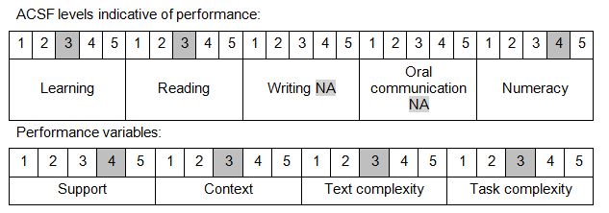

Further information on ACSF and the foundation skills underpinning this unit can be found in the Foundation Skills Guide on the GSA website.

Unit Mapping Information
This unit supersedes and is equivalent to NWP302A Install meters for non-potable, non-urban water supplies.

Links
Companion Volume implementation guides are found in VETNet - https://vetnet.gov.au/Pages/TrainingDocs.aspx?q=26336bc0-04e5-49d9-8c31-46c49b6a0037
Companion Volume implementation guides are found in VETNet - https://vetnet.gov.au/Pages/TrainingDocs.aspx?q=26336bc0-04e5-49d9-8c31-46c49b6a0037
Companion Volume implementation guides are found in VETNet - https://vetnet.gov.au/Pages/TrainingDocs.aspx?q=26336bc0-04e5-49d9-8c31-46c49b6a0037
Companion Volume implementation guides are found in VETNet - https://vetnet.gov.au/Pages/TrainingDocs.aspx?q=26336bc0-04e5-49d9-8c31-46c49b6a0037

