NWPIRR012 Construct open earthen channels or drains
Release: 1

NWPIRR012 Construct open earthen channels or drains

Modification History
Release | Comments
1 | This unit was released in NWP Water Training Package release 1.0 and meets the Standards for Training Packages.  This unit supersedes and is equivalent to NWP251B Construct open earthen channels or drains.  - Unit code updated  - Content and formatting updated to comply with the new standards  - All PC transitioned from passive to active voice  - PC 1.5 revised

Application
This unit of competency describes the skills required to plan and prepare for the construction of open channels or drains and to complete construction operations and subsequent site restoration.
This unit applies to those working as field and operational staff involved in the construction of earthen channels and drains for stormwater or irrigation systems or the remodelling or reconstruction of unserviceable systems.
The skills and knowledge described in this unit must be applied within the legislative, regulatory and policy environment in which they are carried out. Organisational policies and procedures must be consulted and adhered to, particularly those related to WHS and manufacturers’ guidelines.
Those undertaking this unit would work under direct supervision, while performing routine tasks and ensuring minimal damage to the environment, in a familiar context.
No licensing, legislative or certification requirements apply to unit at the time of publication.

Competency Field
Irrigation

Elements and Performance Criteria
ELEMENTS | PERFORMANCE CRITERIA
Elements describe the essential outcomes | Performance criteria describe the performance needed to demonstrate achievement of the element. Where bold italicised text is used, further information is detailed in the range of conditions section.
1. Plan and prepare for construction work | 1.1 Determine work requirements from design plans, specifications, instructions and work orders.  1.2 Check site and identify hazards.  1.3 Make appropriate drainage and diversion arrangements without damage to environment.  1.4 Check equipment and open-cut excavation methods to ensure that safety requirements of task and site are met.  1.5 Select suitable soil material.
2. Construct channels or drains | 2.1 Construct earthen channels, drains and batters to planned width, depth and gradient.  2.2 Compact soil, apply additives and take earth samples.  2.3 Check construction works to ensure that specifications are met.
3. Restore work site and equipment | 3.1 Check, maintain and store equipment, tools and materials.  3.2 Restore work site and add environmental improvements or controls to complete work, according to plans.

Foundation Skills
The foundation skills demands of this unit have been mapped for alignment with the Australian Core Skills Framework (ACSF). The following tables outline the performance levels indicated for successful attainment of the unit.

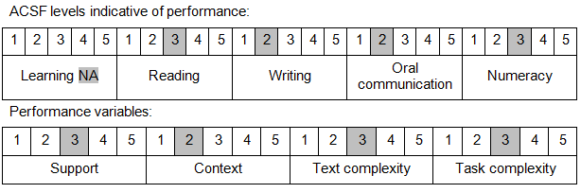

Further information on ACSF and the foundation skills underpinning this unit can be found in the Foundation Skills Guide on the GSA website.

Unit Mapping Information
This unit supersedes and is equivalent to NWP251B Construct open earthen channels and drains.

Links
Companion Volume implementation guides are found in VETNet - https://vetnet.gov.au/Pages/TrainingDocs.aspx?q=26336bc0-04e5-49d9-8c31-46c49b6a0037
Companion Volume implementation guides are found in VETNet - https://vetnet.gov.au/Pages/TrainingDocs.aspx?q=26336bc0-04e5-49d9-8c31-46c49b6a0037
Companion Volume implementation guides are found in VETNet - https://vetnet.gov.au/Pages/TrainingDocs.aspx?q=26336bc0-04e5-49d9-8c31-46c49b6a0037
Companion Volume implementation guides are found in VETNet - https://vetnet.gov.au/Pages/TrainingDocs.aspx?q=26336bc0-04e5-49d9-8c31-46c49b6a0037

