NWPIRR011 Install devices for irrigation systems
Release: 1

NWPIRR011 Install devices for irrigation systems

Modification History
Release | Comments
1 | This unit was released in NWP Water Training Package release 1.0 and meets the Standards for Training Packages.  This unit supersedes and is equivalent to NWP216B Install basic metering equipment and flow control devices for irrigation systems.  - Unit code updated  - Content and formatting updated to comply with the new standards  - All PC transitioned from passive to active voice  - Unit title changed to better reflect unit outcomes  - Elements 2 and 3 merged  - Element 4 removed  - Element 5 reworded  - One new PC added to Element 5

Application
This unit describes the skills required to install devices for irrigation systems. These installations may occur in ground and surface water source irrigation systems.
This unit applies to those working as field and operational staff involved in the installation of water industry metering and flow control devices.
The skills and knowledge described in this unit must be applied within the legislative, regulatory and policy environment in which they are carried out. Organisational policies and procedures must be consulted and adhered to.
Those undertaking this unit would work under supervision, while performing routine tasks in familiar context.
No licensing, legislative or certification requirements apply to unit at the time of publication.

Competency Field
Irrigation

Elements and Performance Criteria
ELEMENTS | PERFORMANCE CRITERIA
Elements describe the essential outcomes | Performance criteria describe the performance needed to demonstrate achievement of the element. Where bold italicised text is used, further information is detailed in the range of conditions section.
1. Plan and prepare work | 1.1 Apply work requirements for installation of flow control and metering devices in irrigation systems from plans, specifications and instructions.  1.2 Prepare work plans to ensure safety within the workplace.  1.3 Select and check equipment and tools to meet safety requirements of the task and site.  1.4 Select, fit and use personal protective equipment.
2. Install devices in irrigation systems | 2.1 Carry out installation of device in irrigation systems.  2.2 Check that installed device meets specifications.
3. Restore site | 3.1 Backfill with suitable material, moisture content and compaction to maximise compaction efficiency.  3.2 Restore the site to original site conditions.

Foundation Skills
The foundation skills demands of this unit have been mapped for alignment with the Australian Core Skills Framework (ACSF). The following tables outline the performance levels indicated for successful attainment of the unit.

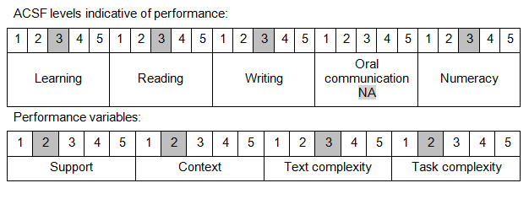
Further information on ACSF and the foundation skills underpinning this unit can be found in the Foundation Skills Guide on the GSA website.

Range of Conditions
Devices include: | - meters  - flow control  - regulating devices

Unit Mapping Information
This unit supersedes and is equivalent to NWP216B Install basic metering equipment and flow control devices for irrigation systems.

Links
Companion Volume implementation guides are found in VETNet - https://vetnet.education.gov.au/Pages/TrainingDocs.aspx?q=26336bc0-04e5-49d9-8c31-46c49b6a0037
Companion Volume implementation guides are found in VETNet - https://vetnet.education.gov.au/Pages/TrainingDocs.aspx?q=26336bc0-04e5-49d9-8c31-46c49b6a0037
Companion Volume implementation guides are found in VETNet - https://vetnet.education.gov.au/Pages/TrainingDocs.aspx?q=26336bc0-04e5-49d9-8c31-46c49b6a0037
Companion Volume implementation guides are found in VETNet - https://vetnet.education.gov.au/Pages/TrainingDocs.aspx?q=26336bc0-04e5-49d9-8c31-46c49b6a0037

