NWPIRR003 Inspect and operate surface water systems
Release: 1

NWPIRR003 Inspect and operate surface water systems

Modification History
Release | Comments
1 | This unit was released in NWP Water Training Package release 1.0 and meets the Standards for Training Packages.  This unit supersedes and is equivalent to NWP322B Inspect and operate surface water systems.  - Unit code updated  - Content and formatting updated to comply with the new standards  - All PC transitioned from passive to active voice  - PC 1.3 removed

Application
This unit describes the skills required to inspect and coordinate the operation of surface water systems and to measure and report on surface water usage and system performance. The ability to collect data, monitor and adjust regulatory systems, coordinate system performance and produce technical reports are essential to performance.
This unit applies to those working as field operators with a specific responsibility for inspecting and operating surface water systems and for ensuring that flows are regulated according to organisational specifications and system demands.
The skills and knowledge described in this unit must be applied within the legislative, regulatory and policy environment in which they are carried out. Organisational policies and procedures must be consulted and adhered to, particularly those related to WHS.
Those undertaking this unit would work under indirect supervision, while performing routine tasks ensuring minimum damage to the environment, in a familiar context.
No licensing, legislative or certification requirements apply to unit at the time of publication.

Competency Field
Irrigation

Elements and Performance Criteria
ELEMENTS | PERFORMANCE CRITERIA
Elements describe the essential outcomes | Performance criteria describe the performance needed to demonstrate achievement of the element. Where bold italicised text is used, further information is detailed in the range of conditions section.
1. Inspect and report on surface water system performance and usage | 1.1 Schedule and complete routine inspections of surface supply areas.  1.2 Collect and record data on system capacity and flow.  1.3 Select, fit and use required safety equipment, including personal protective equipment.
2. Monitor inflows, outflows and releases | 2.1 Inspect flow regulating systems and make adjustments to meet demand requirements.  2.2 Monitor flows and coordinate diversions or extractions to control usage.  2.3 Read meters and record volumes.
3. Operate and coordinate system performance | 3.1 Address and record process faults and operational conditions.  3.2 Optimise process performance.
4. Complete documentation | 4.1 Record inspections results.  4.2 Report data from inspection results.

Foundation Skills
The foundation skills demands of this unit have been mapped for alignment with the Australian Core Skills Framework (ACSF). The following tables outline the performance levels indicated for successful attainment of the unit.

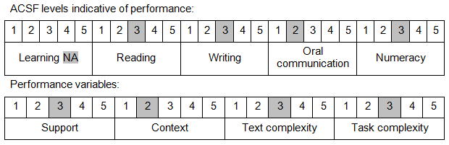

Further information on ACSF and the foundation skills underpinning this unit can be found in the Foundation Skills Guide on the GSA website.

Unit Mapping Information
This unit supersedes and is equivalent to NWP322B Inspect and operate surface water systems.

Links
Companion Volume implementation guides are found in VETNet - https://vetnet.education.gov.au/Pages/TrainingDocs.aspx?q=26336bc0-04e5-49d9-8c31-46c49b6a0037
Companion Volume implementation guides are found in VETNet - https://vetnet.education.gov.au/Pages/TrainingDocs.aspx?q=26336bc0-04e5-49d9-8c31-46c49b6a0037
Companion Volume implementation guides are found in VETNet - https://vetnet.education.gov.au/Pages/TrainingDocs.aspx?q=26336bc0-04e5-49d9-8c31-46c49b6a0037
Companion Volume implementation guides are found in VETNet - https://vetnet.education.gov.au/Pages/TrainingDocs.aspx?q=26336bc0-04e5-49d9-8c31-46c49b6a0037

