NWPIRR002 Operate basic flow control and regulating devices in irrigation systems
Release: 1

NWPIRR002 Operate basic flow control and regulating devices in irrigation systems

Modification History
Release | Comments
1 | This unit was released in NWP Water Training Package release 1.0 and meets the Standards for Training Packages.  This unit supersedes and is equivalent to NWP222A Operate basic flow control and regulating devices in irrigation systems.  - Unit code updated  - Content and formatting updated to comply with the new standards  - All PC transitioned from passive to active voice  - Elements 1 and 2 merged  - PC 2.2 removed  - PC 4.2 and 4.3 reworded

Application
This unit describes the skills required to operate basic flow control and regulating devices in irrigation systems.
This unit applies to those working as field and operational staff with responsibility for using flow control and metering devices according to organisational procedures.
The skills and knowledge described in this unit must be applied within the legislative, regulatory and policy environment in which they are carried out. Organisational policies and procedures must be consulted and adhered to.
Those undertaking this unit would work independently or in a team, under direct supervision using own familiar resources as required, while performing routine tasks in range of familiar contexts.
No licensing, legislative or certification requirements apply to unit at the time of publication.

Competency Field
Irrigation

Elements and Performance Criteria
ELEMENTS | PERFORMANCE CRITERIA
Elements describe the essential outcomes | Performance criteria describe the performance needed to demonstrate achievement of the element. Where bold italicised text is used, further information is detailed in the range of conditions section.
1. Monitor and regulate required flows in irrigation systems | 1.1 Access and apply operating requirements for flows in irrigation systems.  1.2 Use equipment to assist operational activities.  1.3 Monitor, measure and record flows at designated locations and systems according to schedule.  1.4 Identify potential operational problems and provide proactive advice.  1.5 Adjust flow regulation and control mechanisms to increase and decrease flow.
2. Record and report system adjustments | 2.1 Produce information relating to flow adjustments.  2.2 Collect, record and report information on flows and abnormalities.
3. Respond to contingencies | 3.1 Identify and assess potential risks and contingencies in the operation of flow control and regulating devices.  3.2 Respond to potential and actual risks and contingencies.  3.3 Inform relevant personnel within organisation of potential risks.

Foundation Skills
The foundation skills demands of this unit have been mapped for alignment with the Australian Core Skills Framework (ACSF). The following tables outline the performance levels indicated for successful attainment of the unit.
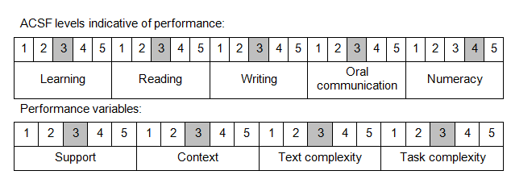

Further information on ACSF and the foundation skills underpinning this unit can be found in the Foundation Skills Guide on the GSA website..

Unit Mapping Information
This unit supersedes and is equivalent to NWP222A Operate basic flow control and regulating devices in irrigation systems.

Links
Companion Volume implementation guides are found in VETNet - https://vetnet.gov.au/Pages/TrainingDocs.aspx?q=26336bc0-04e5-49d9-8c31-46c49b6a0037
Companion Volume implementation guides are found in VETNet - https://vetnet.gov.au/Pages/TrainingDocs.aspx?q=26336bc0-04e5-49d9-8c31-46c49b6a0037
Companion Volume implementation guides are found in VETNet - https://vetnet.gov.au/Pages/TrainingDocs.aspx?q=26336bc0-04e5-49d9-8c31-46c49b6a0037
Companion Volume implementation guides are found in VETNet - https://vetnet.gov.au/Pages/TrainingDocs.aspx?q=26336bc0-04e5-49d9-8c31-46c49b6a0037

