NWPIRR001 Monitor and operate irrigation and domestic delivery systems
Release: 1

NWPIRR001 Monitor and operate irrigation and domestic delivery systems

Modification History
Release | Comments
1 | This unit was released in NWP Water Training Package release 1.0 and meets the Standards for Training Packages.  This unit supersedes and is equivalent to NWP213B Monitor and operate irrigation, stock and domestic delivery systems.  - Unit code updated  - Content and formatting updated to comply with the new standards  - All PC transitioned from passive to active voice  - Unit title changed to better reflect unit outcomes  - One new PC added to Element 3

Application
This unit describes the skills required to operate and check irrigation, stock and domestic supply systems to ensure the delivery of water.
This unit applies to those working as field and operational staff with responsibility for delivering raw water supplies to meet customer orders.
The skills and knowledge described in this unit must be applied within the legislative, regulatory and policy environment in which they are carried out. Organisational policies and procedures must be consulted and adhered to, particularly those related to WHS and flow measurement.
Those undertaking this unit would work independently or in a team, under direct supervision using own familiar resources as required, while performing routine tasks in range of familiar contexts.
No licensing, legislative or certification requirements apply to unit at the time of publication.

Competency Field
Irrigation

Elements and Performance Criteria
ELEMENTS | PERFORMANCE CRITERIA
Elements describe the essential outcomes | Performance criteria describe the performance needed to demonstrate achievement of the element. Where bold italicised text is used, further information is detailed in the range of conditions section.
1. Interpret delivery requirements | 1.1 Schedule deliveries according to customer orders and delivery plan.  1.2 Monitor system flow rates or sources to ensure orders can be met.
2. Operate irrigation or stock and domestic supply systems | 2.1 Identify and apply organisational requirements, plans, orders and schedules for the operation of irrigation or stock and domestic supply system.  2.2 Operate irrigation or stock and domestic supply system, using safe work methods and appropriate equipment.  2.3 Monitor deliveries, record adjustments and irregularities, and communicate as required.
3. Identify and address issues | 3.1 Identify actual and potential problems that may reduce service standards and communicate to relevant personnel.  3.2 Resolve identified problems within own capability.  3.3 Record and report workplace activities.

Foundation Skills
The foundation skills demands of this unit have been mapped for alignment with the Australian Core Skills Framework (ACSF). The following tables outline the performance levels indicated for successful attainment of the unit.

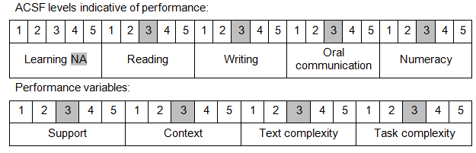

Further information on ACSF and the foundation skills underpinning this unit can be found in the Foundation Skills Guide on the GSA website.

Unit Mapping Information
This unit supersedes and is equivalent to NWP213B Monitor and operate irrigation, stock and domestic delivery systems.

Links
Companion Volume implementation guides are found in VETNet - https://vetnet.education.gov.au/Pages/TrainingDocs.aspx?q=26336bc0-04e5-49d9-8c31-46c49b6a0037
Companion Volume implementation guides are found in VETNet - https://vetnet.education.gov.au/Pages/TrainingDocs.aspx?q=26336bc0-04e5-49d9-8c31-46c49b6a0037
Companion Volume implementation guides are found in VETNet - https://vetnet.education.gov.au/Pages/TrainingDocs.aspx?q=26336bc0-04e5-49d9-8c31-46c49b6a0037
Companion Volume implementation guides are found in VETNet - https://vetnet.education.gov.au/Pages/TrainingDocs.aspx?q=26336bc0-04e5-49d9-8c31-46c49b6a0037

