NWPHYD017 Develop and maintain ratings
Release: 1

NWPHYD017 Develop and maintain ratings

Modification History
Release | Comments
1 | These Assessment Requirements were released in NWP Water Training Package release 1.0 and meet the Standards for Training Packages.  This unit supersedes and is equivalent to NWP510A Develop and maintain ratings.  - Unit code updated  - Content and formatting updated to comply with the new standards  - All PC transitioned from passive to active voice  - One new PC added in Element 2  - PC 4.1 removed  - PC 1.1 and 1.2 revised

Application
This unit of competency describes the skills required to establish relationships between variables including stage versus flow and conductivity versus salinity. This unit requires understanding of the processes required to collect data, interpret data, verify data and produce clear reports that conform with organisational and industry standards.

This unit applies to hydrographers employed by the water industry and water operators involved in the monitoring of all the elements of the water cycle and their impact on the related environment.

The skills and knowledge described in this unit must be applied within the legislative, regulatory and policy environment in which they are carried out. Organisational policies and procedures must be consulted and adhered to, particularly those related to WHS, Bureau of Meteorology, World Meteorological Organisation and Australian Standards.

Those undertaking this unit would work autonomously, supervising staff, while performing complex tasks in a broad range of contexts, that could be unpredictable, including remote, confined spaces, near water and/or at heights.

No licensing, legislative or certification requirements apply to unit at the time of publication.

Competency Field
Hydrography

Elements and Performance Criteria
ELEMENTS | PERFORMANCE CRITERIA
Elements describe the essential outcomes | Performance criteria describe the performance needed to demonstrate achievement of the element. Where bold italicised text is used, further information is detailed in the range of conditions section.
1. Review individual measurements | 1.1 Identify monitoring objectives of site and stage discharge ratings requirements.  1.2 Review historical discharge measurements, time series data and stage discharge rating curves and compare against expected trends.  1.3 Use standard processes and software to check, edit and verify field data.  1.4 Correct and adjust inconsistent data.
2. Develop rating curves | 2.1 Analyse existing measurements to establish trends and compare with existing ratings.  2.2 Identify events at monitoring site that can affect stage discharge curve.  2.3 Identify sources of error in ratings.  2.4 Prepare rating curves based on measurements, agreed formulae and mathematical techniques, under a variety of hydraulic conditions and control types.  2.5 Confirm and verify existing trend or define new trend.  2.6 Develop rating curves that comply with industry and client requirements.  2.7 Use theoretical methods to create or extend ratings.  2.8 Document processes and observations to provide traceability and accountability for quality assurance.  2.9 Apply standard formulae to create ratings for pre-calibrated measuring structures.  2.10 Apply quality codes to rating curves.
3. Maintain rating curves | 3.1 Confirm accuracy of rating curves using recent measurements and review trends and rating applicability.  3.2 Develop rating curves based on new information from reviews and changed conditions.  3.3 Retrieve and analyse current, historic and trend data using appropriate mathematical techniques.  3.4 Document processes, observations and adjustments made.
4. Report rating curves | 4.1 Prepare and store required archival data to guarantee data security.  4.2 Prepare and disseminate ratings in accordance with client requirements.  4.3 Make recommendations for future observations.

Foundation Skills
The foundation skills demands of this unit have been mapped for alignment with the Australian Core Skills Framework (ACSF). The following tables outline the performance levels indicated for successful attainment of the unit.
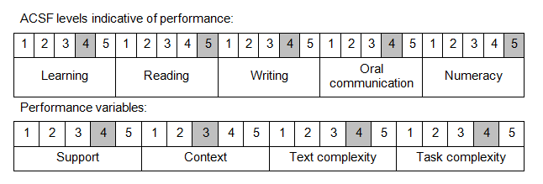
Further information on ACSF and the foundation skills underpinning this unit can be found in the Foundation Skills Guide on the GSA website.

Unit Mapping Information
This unit supersedes and is equivalent to NWP510A Develop and maintain ratings.

Links
GSA website - http://www.govskills.com.au
NWP Implementation Guide - http://www.govskills.com.au/guides/water/implementation-guide
NWP Foundation Skills Guide - http://www.govskills.com.au/guides/water/foundation-skills-guide
NWP Knowledge Guide - http://www.govskills.com.au/guides/water/knowledge-guide

