NWPHYD016 Process and report hydrographic time series data
Release: 1

NWPHYD016 Process and report hydrographic time series data

Modification History
Release | Comments
1 | These Assessment Requirements were released in NWP Water Training Package release 1.0 and meet the Standards for Training Packages.  This unit supersedes and is equivalent to NWP509A Collect, verify and report hydrometric time series data.  - Unit code updated  - Content and formatting updated to comply with the new standards  - All PC transitioned from passive to active voice  - Unit title changed to better reflect unit outcomes  - Elements 1 and 3 all PC reordered  - PC 2.3 revised

Application
This unit describes the skills required to compile, interpret, analyse and verify data includingwater level (streams, lakes), rainfall, groundwater, soil moisture, evaporation, radiation, wind, temperature and electro conductivity. It also describes the skills required to produce hydrometric data reports to support organisational decision making.

This unit applies to hydrographers employed by the water industry and water operators involved in the monitoring of all the elements of the water cycle and their impact on the related environment.

The skills and knowledge described in this unit must be applied within the legislative, regulatory and policy environment in which they are carried out. Organisational policies and procedures must be consulted and adhered to, particularly those relating to WHS, Bureau of Meteorology, World Meteorological Organisation and Australian Standards.

Those undertaking this unit would work autonomously, supervising staff, while performing complex tasks in a broad range of contexts that could be unpredictable, including remote, confined spaces, near water and/or at heights.

No licensing, legislative or certification requirements apply to unit at the time of publication.

Competency Field
Hydrography

Elements and Performance Criteria
ELEMENTS | PERFORMANCE CRITERIA
Elements describe the essential outcomes | Performance criteria describe the performance needed to demonstrate achievement of the element. Where bold italicised text is used, further information is detailed in the range of conditions section.
1. Prepare for collection of data | 1.1 Identify objectives of time series, client’s data and reporting requirements.  1.2 Identify parameters and procedures for collection of hydrometric data.
2. Retrieve time series data | 2.1 Retrieve and manage data.  2.2 Reset data logger.  2.3 Apply and record field verification checks.  2.4 Complete field documentation.
3. Verify hydrometric data | 3.1 Prepare working copy of data.  3.2 Select data to be verified.  3.3 Use standard processes, software, mathematical and scientific techniques to check, edit, verify, adjust and qualify data.  3.4 Review and apply verification information and additional (backup time series) data sets to time series data and identify proposed adjustments to data.  3.5 Use historical data, nearby sites and related parameters to validate data, identify data irregularities and ensure data integrity.  3.6 Estimate failed periods required by client.  3.7 Document checks and adjustments.  3.8 Archive raw and/or processed data.
4. Prepare reports | 4.1 Prepare standard reports to check integrity of verified data.  4.2 Prepare client specific reports.  4.3 Prepare verified data, documentation and reports for authorisation.  4.4 File authorised information.

Foundation Skills
The foundation skills demands of this unit have been mapped for alignment with the Australian Core Skills Framework (ACSF). The following tables outline the performance levels indicated for successful attainment of the unit.
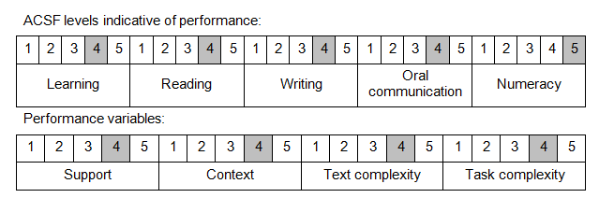

Further information on ACSF and the foundation skills underpinning this unit can be found in the Foundation Skills Guide on the GSA website.

Unit Mapping Information
This unit supersedes and is equivalent to NWP509A Collect, verify and report hydrometric time series data.

Links
GSA website - http://www.govskills.com.au
NWP Implementation Guide - http://www.govskills.com.au/guides/water/implementation-guide
NWP Foundation Skills Guide - http://www.govskills.com.au/guides/water/foundation-skills-guide
NWP Knowledge Guide - http://www.govskills.com.au/guides/water/knowledge-guide

