NWPHYD012 Establish monitoring sites
Release: 1

NWPHYD012 Establish monitoring sites

Modification History
Release | Comments
1 | These Assessment Requirements were released in NWP Water Training Package release 1.0 and meet the Standards for Training Packages.  This unit supersedes and is equivalent to NWP342A Commission, decommission and monitor hydrometric sites, stations and facilities.  - Unit code updated  - Content and formatting updated to comply with the new standards  - All PC transitioned from passive to active voice  - Unit title changed to better reflect unit outcomes  - All Elements reworded  - Element 4 removed  - Two new PC added in Element 1  - One new PC added in Element 2  - PC 1.1 removed  - PC 2.2 and 3.2 revised

Application
This unit of competency describes the skills required to establish monitoring sites to organisational standards. The ability to interpret and apply technical specifications and to establish sites to support the collection of data is central to successful performance.
This unit applies to hydrographers employed by the water industry and to water operators involved in the monitoring of all the elements of the water cycle and their impact on the related environment.
The skills and knowledge described in this unit must be applied within the legislative, regulatory and policy environment in which they are carried out. Organisational policies and procedures must be consulted and adhered to, particularly those relating to WHS, Bureau of Meteorology, World Meteorological Organisation and Australian Standards.
Those undertaking this unit would work in small teams, mostly under supervision, while performing complex tasks in a broad range of contexts, that could be unpredictable, including remote, confined spaces, near water and/or at heights.
No licensing, legislative or certification requirements apply to unit at the time of publication.

Competency Field
Hydrography

Elements and Performance Criteria
ELEMENTS | PERFORMANCE CRITERIA
Elements describe the essential outcomes | Performance criteria describe the performance needed to demonstrate achievement of the element. Where bold italicised text is used, further information is detailed in the range of conditions section.
1. Plan the establishment of monitoring sites and facilities | 1.1 Identify monitoring requirements based on business objectives of the site or facility.  1.2 Identify and confirm the establishment requirements and standard procedures for the site or facility.  1.3 Consult with stakeholders.  1.4 Conduct site investigations and surveys to select sites and equipment fit for purpose.  1.5 Prepare project and risk management plans and designs for the establishment of the site or facility and secure authorisation.
2. Establish the site and facilities | 2.1 Conduct a site specific risk assessment.  2.2 Identify, assemble and check the equipment required for the task prior to use.  2.3 Establish the site or facility according to the project plan.  2.4 Establish and register sites and ancillary infrastructure.  2.5 Complete records of the establishment process.
3. Support data collection | 3.1 Determine and apply instrument and site maintenance schedules.  3.2 Determine and apply testing schedules.  3.3 Put in place processes to monitor instrument performance and take corrective action as required.  3.4 Maintain test records.  3.5 Compile and store reports and documentation.

Foundation Skills
The foundation skills demands of this unit have been mapped for alignment with the Australian Core Skills Framework (ACSF). The following tables outline the performance levels indicated for successful attainment of the unit.
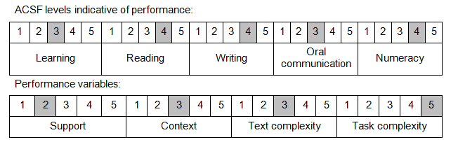
Further information on ACSF and the foundation skills underpinning this unit can be found in the Foundation Skills Guide on the GSA website.

Unit Mapping Information
This unit supersedes and is equivalent to NWP342A Commission, decommission and monitor hydrometric sites, stations and facilities.

Links
Companion Volume implementation guides are found in VETNet - https://vetnet.education.gov.au/Pages/TrainingDocs.aspx?q=26336bc0-04e5-49d9-8c31-46c49b6a0037
Companion Volume implementation guides are found in VETNet - https://vetnet.education.gov.au/Pages/TrainingDocs.aspx?q=26336bc0-04e5-49d9-8c31-46c49b6a0037
Companion Volume implementation guides are found in VETNet - https://vetnet.education.gov.au/Pages/TrainingDocs.aspx?q=26336bc0-04e5-49d9-8c31-46c49b6a0037
Companion Volume implementation guides are found in VETNet - https://vetnet.education.gov.au/Pages/TrainingDocs.aspx?q=26336bc0-04e5-49d9-8c31-46c49b6a0037

