NWPHYD001 Apply principles of open channel hydraulics
Release: 1

NWPHYD001 Apply principles of open channel hydraulics

Modification History
Release | Comments
1 | This unit was released in NWP Water Training Package release 1.0 and meets the Standards for Training Packages.  This unit supersedes and is not equivalent to NWP508A Apply principle of hydraulics to pipe and channel flow.  - Unit code updated  - Content and formatting updated to comply with the new standards  - All PC transitioned from passive to active voice  - Unit title changed to better reflect unit outcomes  - All Elements and PC revised

Application
This unit describes the skills required to use hydraulic principles and calculations of theoretical flows. An understanding of the processes required to collect data accurately, interpret data, verify data and apply theoretical techniques to produce flow data is essential to performance.

This unit applies to hydrographers employed by the water industry and water operators involved in the monitoring of all the elements of the water cycle and their impact on the related environment.

The skills and knowledge described in this unit must be applied within the legislative, regulatory and policy environment in which they are carried out. Organisational policies and procedures must be consulted and adhered to, particularly those relating to WHS, Bureau of Meteorology, World Meteorological Organisation and Australian Standards.

Those undertaking this unit would work in small teams, autonomously or under supervision, while performing complex tasks in a broad range of contexts that could be unpredictable, including remote, confined spaces, near water and/or at heights.

No licensing, legislative or certification requirements apply to unit at the time of publication.

Competency Field
Hydrography

Elements and Performance Criteria
ELEMENTS | PERFORMANCE CRITERIA
Elements describe the essential outcomes | Performance criteria describe the performance needed to demonstrate achievement of the element. Where bold italicised text is used, further information is detailed in the range of conditions section.
1. Select open channel hydraulic methodology | 1.1 Identify monitoring objectives of the site and hydraulic calculation requirements.  1.2 Select methodology for open channel hydraulic calculations.  1.3 Identify hydraulic principles used for verification of calculations.  1.4 Select other methodologies to review initial calculations.
2. Collect and review data for flow calculations | 2.1 Measure and collect appropriate data to calculate theoretical flows based on methodology selected.  2.2 Determine the hydraulic characteristics of a monitoring site.  2.3 Measure and collect appropriate data to calculate flows theoretically.  2.4 Estimate hydraulic coefficients based on observations.  2.5 Prepare records in a format suitable for dissemination.  2.6 Review data collected and subsequent calculations for inconsistencies against measured flows.
3. Select the appropriate control structure | 3.1 Select the appropriate control structures based on the characteristics of the open channel and its catchment.  3.2 Identify and determine the method to calculate flow by using the appropriate formulae for the control structure.
4. Calculate flow in open channels | 4.1 Select and use the appropriate formulae for calculating flows in open channels based on the characteristics of the open channel and its catchment.  4.2 Identify the limitations of the formulae.  4.3 Identify factors that would cause variations in the results.  4.4 Verify results by applying hydraulic principles and other methodologies.  4.5 Determine the characteristics of open channel pipe flow.
5. Calculate flow from pressure measurements | 5.1 Determine flow-based calculations by using pressure instruments.  5.2 Make adjustments for absolute pressure instruments to measure head in open channels.  5.3 Make corrections in pressure measurements to allow for head measurement of salt water.

Foundation Skills
The foundation skills demands of this unit have been mapped for alignment with the Australian Core Skills Framework (ACSF). The following tables outline the performance levels indicated for successful attainment of the unit.

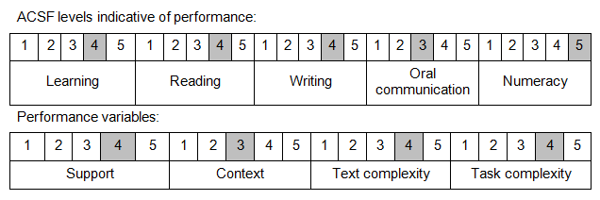

Further information on ACSF and the foundation skills underpinning this unit can be found in the Foundation Skills Guide on the GSA website.

Unit Mapping Information
No equivalent unit

Links
GSA website - http://www.govskills.com.au
NWP Implementation Guide - http://www.govskills.com.au/guides/water/implementation-guide
NWP Foundation Skills Guide - http://www.govskills.com.au/guides/water/foundation-skills-guide
NWP Knowledge Guide - http://www.govskills.com.au/guides/water/knowledge-guide

