NWPGEN014 Sample and test trade wastewater
Release: 1

NWPGEN014 Sample and test trade wastewater

Modification History
Release | Comments
1 | This unit was released in NWP Water Training Package release 1.0 and meets the Standards for Training Packages.

Application
This unit describes the skills required to collect and prepare trade wastewater samples, perform basic field based tests and conduct and record analysis.
This unit applies to those working in the water industry but might be relevant to others.
The skills and knowledge described in this unit must be applied within the legislative, regulatory and policy environment in which they are carried out. Organisational policies and procedures must be consulted and adhered to.
Those undertaking this unit would work under indirect supervision, while performing complex tasks in familiar contexts.
No licensing, legislative or certification requirements apply to unit at the time of publication.

Competency Field
General

Elements and Performance Criteria
ELEMENTS | PERFORMANCE CRITERIA
Elements describe the essential outcomes | Performance criteria describe the performance needed to demonstrate achievement of the element. Where bold italicised text is used, further information is detailed in the range of conditions section.
1. Prepare for trade wastewater sampling and testing | 1 1 Identify the need to sample based on trade waste customer risk, sewer catchment and infrastructure issues.  1.2 Schedule sampling and testing in accordance with a monitoring program.  1.3 Identify wastewater quality parameters to be tested for.  1.4 Identify appropriate sampling location and type of sample to be taken in accordance with the monitoring program.  1.5 Communicate with an external laboratory regarding sampling, preservation, parameters to be analysed and transportation requirements.  1.6 Select and apply sample preservation methods.  1.7 Select, check, calibrate and prepare equipment and resources.  1.8 Select, fit and use personal protective equipment.
2. Conduct trade wastewater sampling and testing | 2.1 Adopt hygienic work practices.  2.2 Carry out job safety analysis or risk assessment.  2.3 Determine sampling method, either manual or automatic and time based or flow based.  2.4 Sample and determine the trade wastewater related to the typical operation of the business.  2.5 Collect samples ensuring that types, locations and times comply with requirements.  2.6 Maintain integrity of samples during sampling and field testing.  2.7 Conduct basic field trade wastewater tests.  2.8 Assess and report abnormal characteristics and undertake corrective action.  2.9 Limit hazards and contamination to self, work area and environment.
3. Finalise work | 3.1 Apply chain of custody procedures.  3.2 Organise transportation of samples to the laboratory.  3.3 Report observations or measurements requiring further action.  3.4 Clean testing equipment and sampling site.  3.5 Record analysis results from field testing and laboratory testing.  3.6 Interpret test results, assess compliance and reschedule sampling to confirm findings.

Foundation Skills
The foundation skills demands of this unit have been mapped for alignment with the Australian Core Skills Framework (ACSF). The following tables outline the performance levels indicated for successful attainment of the unit.

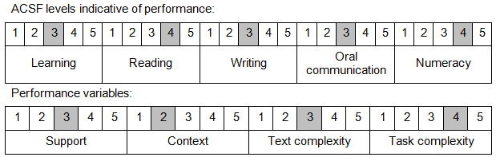

Further information on ACSF and the foundation skills underpinning this unit can be found in the Foundation Skills Guide on the GSA website.

Range of Conditions
Field testing includes: | - pH  - temperature  - conductivity  - metals  - colour  - visual assessment  - odour  - sulphides
Sampling processes include: | - automatic  - flow proportional composites  - time proportional composites  - discreet manual

Unit Mapping Information
No equivalent unit.

Links
Companion Volume implementation guides are found in VETNet - https://vetnet.gov.au/Pages/TrainingDocs.aspx?q=26336bc0-04e5-49d9-8c31-46c49b6a0037
Companion Volume implementation guides are found in VETNet - https://vetnet.gov.au/Pages/TrainingDocs.aspx?q=26336bc0-04e5-49d9-8c31-46c49b6a0037
Companion Volume implementation guides are found in VETNet - https://vetnet.gov.au/Pages/TrainingDocs.aspx?q=26336bc0-04e5-49d9-8c31-46c49b6a0037
Companion Volume implementation guides are found in VETNet - https://vetnet.gov.au/Pages/TrainingDocs.aspx?q=26336bc0-04e5-49d9-8c31-46c49b6a0037

