NWPGEN012 Support the role and functions of the water industry
Release: 1

NWPGEN012 Support the role and functions of the water industry

Modification History
Release | Comments
1 | This unit was released in NWP Water Training Package release 1.0 and meets the Standards for Training Packages.  - New unit  - Created drawing upon information from deleted units NWP201B and NWP207A

Application
This unit describes the skills required to work effectively in the water industry by understanding the role of water organisations in the community, services they provide, water systems used, the importance of maintaining water quality, and structure of organisations. The ability to understand the water cycle and the link between the services and systems of the water organisation and supply to, and usage by, the consumer is essential to performance.
This unit applies to those working in the water industry.
The skills and knowledge described in this unit must be applied within the legislative, regulatory and policy environment in which they are carried out. Organisational policies and procedures must be consulted and adhered to.
Those undertaking this unit would work under supervision, while performing specific tasks in a range of familiar contexts.
No licensing, legislative or certification requirements apply to unit at the time of publication.

Competency Field
General

Elements and Performance Criteria
ELEMENTS | PERFORMANCE CRITERIA
Elements describe the essential outcomes | Performance criteria describe the performance needed to demonstrate achievement of the element. Where bold italicised text is used, further information is detailed in the range of conditions section.
1. Identify elements of the water cycle | 1.1 Describe the natural water cycle.  1.2 Outline human intervention on natural water cycle and its environmental impact.
2. Determine functions of water systems | 2.1 Identify streams within water industry.  2.2 Determine functions of each stream.  2.3 Identify how each stream relates to the water cycle.  2.4 Consider sustainable practices.  2.5 Consider ways to increase sources of water supply.  2.6 Identify and describe methods and procedures to maintain water quality.
3. Recognise stakeholders and customers | 3.1 Identify customers and services provided to them.  3.2 Identify stakeholders and respective roles.  3.3 Explore and describe the structure of the water industry at local, state, territory and national level.
4. Identify legislative framework | 4.1 Identify bodies responsible for establishing and managing standards for water quality.  4.2 Identify relevant guidelines.  4.3 Determine legislative, regulatory and licensing requirements governing the industry and understand their impact.  4.4 Recognise the principles of compliance.
5. Translate into own role in organisational and work context | 5.1 Review and describe organisation management structure and role relationships.  5.2 Review and apply organisation key policies and procedures.  5.3 Review and apply standard reporting procedures and identify impact on own work.  5.4 Describe how own role contributes to quality outcomes.

Foundation Skills
The foundation skills demands of this unit have been mapped for alignment with the Australian Core Skills Framework (ACSF). The following tables outline the performance levels indicated for successful attainment of the unit.

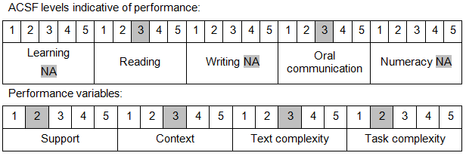

Further information on ACSF and the foundation skills underpinning this unit can be found in the Foundation Skills Guide on the GSA website.

Range of Conditions
Streams within the water industry include: | - hydrography  - treatment  - source  - networks  - trade waste  - irrigation

Unit Mapping Information
No equivalent unit.

Links
Companion Volume implementation guides are found in VETNet - https://vetnet.education.gov.au/Pages/TrainingDocs.aspx?q=26336bc0-04e5-49d9-8c31-46c49b6a0037
Companion Volume implementation guides are found in VETNet - https://vetnet.education.gov.au/Pages/TrainingDocs.aspx?q=26336bc0-04e5-49d9-8c31-46c49b6a0037
Companion Volume implementation guides are found in VETNet - https://vetnet.education.gov.au/Pages/TrainingDocs.aspx?q=26336bc0-04e5-49d9-8c31-46c49b6a0037
Companion Volume implementation guides are found in VETNet - https://vetnet.education.gov.au/Pages/TrainingDocs.aspx?q=26336bc0-04e5-49d9-8c31-46c49b6a0037

