NWPGEN011 Use maps, plans, drawings and specifications
Release: 1

NWPGEN011 Use maps, plans, drawings and specifications

Modification History
Release | Comments
1 | These Assessment Requirements were released in NWP Water Training Package release 1.0 and meet the Standards for Training Packages.  - New unit  - Created drawing upon information from deleted units NWP209B and NWP105B

Application
This unit describes the skills required to read and interpret maps, plans, drawings and specifications and prepare a simple map or plan.
This unit applies to those working in the water industry, but could be used by other sectors.
The skills and knowledge described in this unit must be applied within the legislative, regulatory and policy environment in which they are carried out. Organisational policies and procedures must be consulted and adhered to.
Those undertaking this unit would work under supervision, while performing routine tasks in a range of contexts.
No licensing, legislative or certification requirements apply to unit at the time of publication.

Competency Field
General

Elements and Performance Criteria
ELEMENTS | PERFORMANCE CRITERIA
Elements describe the essential outcomes | Performance criteria describe the performance needed to demonstrate achievement of the element. Where bold italicised text is used, further information is detailed in the range of conditions section.
1. Interpret maps, plans, drawings and specifications | 1.1 Identify types of maps, plans, drawings and specifications required to undertake work tasks.  1.2 Identify parts of the water system and their inter-relationship on a range of drawing types.  1.3 Interpret commonly used symbols and abbreviations.  1.4 Interpret and apply the function of the legend.  1.5 Verify latest version.  1.6 Identify natural and man-made features on maps, plans and drawings.  1.7 Relate specifications to maps, plans and drawings and identify quality standards.  1.8 Identify types of details from works specifications.
2. Use maps, plans drawings and specifications | 2.1 Use organisation system to access maps plans, drawings and specifications.  2.2 Translate technical data and apply quality standards into work site environment.  2.3 Calculate distances using maps and plans with a range of scales.  2.4 Confirm orientation, boundaries and identified features of the site.  2.5 Identify any errors in the maps, plans, drawings and specifications.
3. Record and advise on changes and errors | 3.1 Draw or amend a map or plan.  3.2 Take actual measurements and record features on a map or drawing.  3.3 Record and report amendments.

Foundation Skills
The foundation skills demands of this unit have been mapped for alignment with the Australian Core Skills Framework (ACSF). The following tables outline the performance levels indicated for successful attainment of the unit.

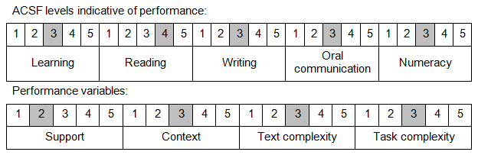

Further information on ACSF and the foundation skills underpinning this unit can be found in the Foundation Skills Guide on the GSA website.

Unit Mapping Information
No equivalent unit.

Links
Companion Volume implementation guides are found in VETNet - https://vetnet.gov.au/Pages/TrainingDocs.aspx?q=26336bc0-04e5-49d9-8c31-46c49b6a0037
Companion Volume implementation guides are found in VETNet - https://vetnet.gov.au/Pages/TrainingDocs.aspx?q=26336bc0-04e5-49d9-8c31-46c49b6a0037
Companion Volume implementation guides are found in VETNet - https://vetnet.gov.au/Pages/TrainingDocs.aspx?q=26336bc0-04e5-49d9-8c31-46c49b6a0037
Companion Volume implementation guides are found in VETNet - https://vetnet.gov.au/Pages/TrainingDocs.aspx?q=26336bc0-04e5-49d9-8c31-46c49b6a0037

