NWPGEN010 Contribute to continuous improvement of quality systems
Release: 1

NWPGEN010 Contribute to continuous improvement of quality systems

Modification History
Release | Comments
1 | This unit was released in NWP Water Training Package release 1.0 and meets the Standards for Training Packages.  This unit supersedes and is equivalent to NWP432A Contribute to the continuous improvement of quality systems.  - Unit code updated  - Content and formatting updated to comply with the new standards  - All PC transitioned from passive to active voice  - Unit title changed to better reflect unit outcomes  - One new PC added in Element 1  - PC 1.2 revised

Application
This unit describes the skills required to understand and implement quality systems in the water industry and to identify opportunities for improvement in quality outcomes for the organisation.
This unit applies to those working as water industry technicians or supervisors with a responsibility for the implementation of quality systems.
The skills and knowledge described in this unit must be applied within the legislative, regulatory and policy environment in which they are carried out. Organisational policies and procedures must be consulted and adhered to.
Those undertaking this unit would work autonomously, usually with supervisory responsibilities, while performing complex tasks in a range of contexts.
No licensing, legislative or certification requirements apply to unit at the time of publication.

Competency Field
General

Elements and Performance Criteria
ELEMENTS | PERFORMANCE CRITERIA
Elements describe the essential outcomes | Performance criteria describe the performance needed to demonstrate achievement of the element. Where bold italicised text is used, further information is detailed in the range of conditions section.
1. Interpret and communicate quality system requirements | 1.1 Interpret the accreditation requirements for relevant water quality systems.  1.2 Identify implications of non-conformance with quality accreditation requirements.  1.3 Communicate requirements and implications to work colleagues.  1.4 Review standard operating procedures to ensure compliance with current quality accreditation and legislative requirements.
2. Implement quality systems | 2.1 Define individual roles and responsibilities in quality system implementation.  2.2 Implement standard operating procedures to ensure compliance with quality systems.  2.3 Record relevant data for quality system monitoring.  2.4 Record and report observations of non-conformance with quality accreditation requirements.
3. Identify and correct quality system implementation problems | 3.1 Analyse system monitoring data to identify variances that indicate abnormal or sub-optimal performance.  3.2 Review non-conformance reports to identify contributing factors.  3.3 Identify corrective action to remove or control the risk of sub-optimal performance.
4. Contribute to improvement of quality system implementation | 4.1 Develop recommendations for continuous improvement of work practices, methods, equipment and procedures.  4.2 Consult all relevant work colleagues to refine recommendations.  4.3 Document recommendations for quality system implementation improvements and record the required modifications in standard operating procedures.

Foundation Skills
The foundation skills demands of this unit have been mapped for alignment with the Australian Core Skills Framework (ACSF). The following tables outline the performance levels indicated for successful attainment of the unit.

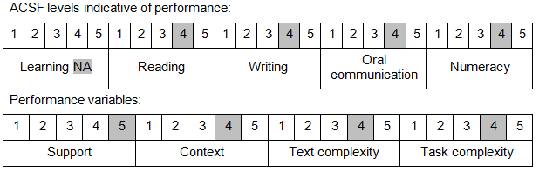

Further information on ACSF and the foundation skills underpinning this unit can be found in the Foundation Skills Guide on the GSA website.

Unit Mapping Information
This unit supersedes and is equivalent to NWP432A Contribute to the continuous improvement of quality systems.

Links
Companion Volume implementation guides are found in VETNet - https://vetnet.gov.au/Pages/TrainingDocs.aspx?q=26336bc0-04e5-49d9-8c31-46c49b6a0037
Companion Volume implementation guides are found in VETNet - https://vetnet.gov.au/Pages/TrainingDocs.aspx?q=26336bc0-04e5-49d9-8c31-46c49b6a0037
Companion Volume implementation guides are found in VETNet - https://vetnet.gov.au/Pages/TrainingDocs.aspx?q=26336bc0-04e5-49d9-8c31-46c49b6a0037
Companion Volume implementation guides are found in VETNet - https://vetnet.gov.au/Pages/TrainingDocs.aspx?q=26336bc0-04e5-49d9-8c31-46c49b6a0037

