NWPGEN008 Sample and test wastewater
Release: 1

NWPGEN008 Sample and test wastewater

Modification History
Release | Comments
1 | This unit was released in NWP Water Training Package release 1.0 and meets the Standards for Training Packages.  - New unit  - Created drawing upon information from deleted units NWP210B and NWP218B

Application
This unit describes the skills required to collect and prepare wastewater samples and to perform basic wastewater tests. This unit does not include off-site laboratory testing.
This unit applies to those working in field operations within the water industry, but might be relevant to others.
The skills and knowledge described in this unit must be applied within the legislative, regulatory and policy environment in which they are carried out. Organisational policies and procedures must be consulted and adhered to.
Those undertaking this unit would work under supervision, while performing routine tasks in a range of familiar contexts.
No licensing, legislative or certification requirements apply to unit at the time of publication.

Competency Field
General

Elements and Performance Criteria
ELEMENTS | PERFORMANCE CRITERIA
Elements describe the essential outcomes | Performance criteria describe the performance needed to demonstrate achievement of the element. Where bold italicised text is used, further information is detailed in the range of conditions section.
1. Prepare for wastewater sampling and testing | 1.1 Receive instructions for taking samples and conducting basic water quality tests.  1.2 Confirm and record samples and tests to comply with requirements.  1.3 Select, check and prepare equipment and resources.  1.4 Select and apply relevant sample preservation methods.  1.5 Select, fit and use personal protective equipment.
2. Conduct wastewater sampling and testing | 2.1 Adopt hygienic work practices.  2.2 Collect samples ensuring that types, locations and times comply with requirements.  2.3 Prepare samples for off-site laboratory testing according to requirements.  2.4 Maintain integrity of samples during sampling and on-site testing.  2.5 Conduct basic on-site wastewater tests.  2.6 Assess and report abnormal characteristics and apply incident management principles.  2.7 Record samples and results of on-site analysis.  2.8 Limit hazards and contamination to self, work area and environment.
3. Finalise work | 3.1 Apply chain of custody principles.  3.2 Report observations or measurements requiring further action.  3.3 Dispose of samples and clean and store test equipment.  3.4 Clear and restore work area.

Foundation Skills
The foundation skills demands of this unit have been mapped for alignment with the Australian Core Skills Framework (ACSF). The following tables outline the performance levels indicated for successful attainment of the unit.

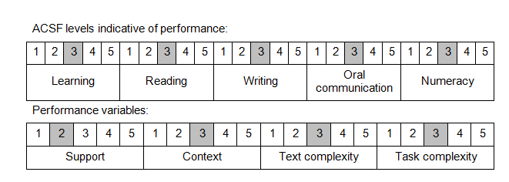

Further information on ACSF and the foundation skills underpinning this unit can be found in the Foundation Skills Guide on the GSA website.

Range of Conditions
On-site test include: | - turbidity  - pH  - dissolved oxygen  - electrical conductivity  - temperature
Sampling conditions include: | - physical  - microbial  - chemical  - radiological
Sampling methods include: | - automatic  - manual

Unit Mapping Information
No equivalent unit.

Links
Companion Volume implementation guides are found in VETNet - https://vetnet.gov.au/Pages/TrainingDocs.aspx?q=26336bc0-04e5-49d9-8c31-46c49b6a0037
Companion Volume implementation guides are found in VETNet - https://vetnet.gov.au/Pages/TrainingDocs.aspx?q=26336bc0-04e5-49d9-8c31-46c49b6a0037
Companion Volume implementation guides are found in VETNet - https://vetnet.gov.au/Pages/TrainingDocs.aspx?q=26336bc0-04e5-49d9-8c31-46c49b6a0037
Companion Volume implementation guides are found in VETNet - https://vetnet.gov.au/Pages/TrainingDocs.aspx?q=26336bc0-04e5-49d9-8c31-46c49b6a0037

