NWPGEN005 Coordinate and monitor the application of environmental plans and procedures
Release: 1

NWPGEN005 Coordinate and monitor the application of environmental plans and procedures

Modification History
Release | Comments
1 | This unit was released in NWP Water Training Package release 1.0 and meets the Standards for Training Packages.  This unit supersedes and is equivalent to NWP401B Coordinate and monitor the application of environmental plans and procedures.  - Unit code updated  - Content and formatting updated to comply with the new standards  - All PC transitioned from passive to active voice  - PC 2.5 removed  - PC 3.4 and 5.3 revised

Application
This unit describes the skills required to monitor and coordinate the application of environmental plans and procedures to specific projects and to develop environmental procedures for the local work area.
This unit applies to those working in the water industry with a specific responsibility for ensuring that all relevant environmental plans and policies are applied to each project and work site within the scope of their job role, and for ensuring that environmental plans and policies are implemented, monitored, reviewed and reported according to organisational and statutory requirements.
The skills and knowledge described in this unit must be applied within the legislative, regulatory and policy environment in which they are carried out. Organisational policies and procedures must be consulted and adhered to.
Those undertaking this unit would work autonomously while performing complex tasks, in a range of familiar contexts.
No licensing, legislative or certification requirements apply to unit at the time of publication.

Competency Field
General

Elements and Performance Criteria
ELEMENTS | PERFORMANCE CRITERIA
Elements describe the essential outcomes | Performance criteria describe the performance needed to demonstrate achievement of the element. Where bold italicised text is used, further information is detailed in the range of conditions section.
1. Determine relevant environmental plans and procedures | 1.1 Identify environmental plans and procedures and determine relevance to specific projects or work sites.  1.2 Interpret relevant environmental plans and procedures in relation to specific project or site activities.
2. Implement environmental plans and procedures | 2.1 Identify environmental risks and impacts.  2.2 Manage and minimise environmental risks.  2.3 Apply emergency procedures.  2.4 Carry out activities according to environmental plans and procedures.
3. Manage project or site specific environmental procedures | 3.1 Assess the need for project or site specific environmental procedures.  3.2 Consult stakeholders and address issues and concerns.  3.3 Develop specific project or site environmental procedures.  3.4 Review and maintain specific project or site environmental procedures.
4. Control environmental incidents | 4.1 Identify environmental incidents at site and apply appropriate control measures.  4.2 Analyse environmental incidents to prevent recurrence.  4.3 Record and report environmental incidents and complete environmental management documentation.
5. Monitor and report on environmental plans and procedures | 5.1 Monitor and report on the implementation of environmental plans and procedures.  5.2 Report environmental risks.  5.3 Coordinate reviews of environmental procedures and report.

Foundation Skills
The foundation skills demands of this unit have been mapped for alignment with the Australian Core Skills Framework (ACSF). The following tables outline the performance levels indicated for successful attainment of the unit.

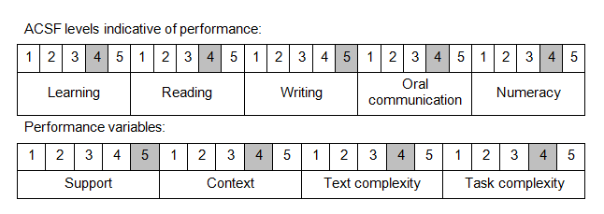

Further information on ACSF and the foundation skills underpinning this unit can be found in the Foundation Skills Guide on the GSA website.

Unit Mapping Information
This unit supersedes and is equivalent to NWP401B Coordinate and monitor the application of environmental plans and procedures.

Links
Companion Volume implementation guides are found in VETNet - https://vetnet.gov.au/Pages/TrainingDocs.aspx?q=26336bc0-04e5-49d9-8c31-46c49b6a0037
Companion Volume implementation guides are found in VETNet - https://vetnet.gov.au/Pages/TrainingDocs.aspx?q=26336bc0-04e5-49d9-8c31-46c49b6a0037
Companion Volume implementation guides are found in VETNet - https://vetnet.gov.au/Pages/TrainingDocs.aspx?q=26336bc0-04e5-49d9-8c31-46c49b6a0037
Companion Volume implementation guides are found in VETNet - https://vetnet.gov.au/Pages/TrainingDocs.aspx?q=26336bc0-04e5-49d9-8c31-46c49b6a0037

