NWPGEN003 Apply environmental and licensing procedures of the water industry
Release: 1

NWPGEN003 Apply environmental and licensing procedures of the water industry

Modification History
Release | Comments
1 | This unit was released in NWP Water Training Package release 1.0 and meets the Standards for Training Packages.  This unit supersedes and is equivalent to NWP202B Apply environmental and licensing procedures.  - Unit code updated  - Content and formatting updated to comply with the new standards  - All PC transitioned from passive to active voice  - Unit title changed to better reflect unit outcomes

Application
This unit describes the skills required to implement established environmental and licensing procedures and contribute to improving environmental practices in the water industry, and identify and minimise environmental risks and the impact of work-related activities on the local environment.
This unit applies to those working in a range of roles within the water industry.
The skills and knowledge described in this unit must be applied within the legislative, regulatory and policy environment in which they are carried out. Organisational policies and procedures must be consulted and adhered to.
Those undertaking this unit would work under indirect supervision while performing specific tasks in a broad range of contexts.
No licensing, legislative or certification requirements apply to unit at the time of publication.

Competency Field
General

Elements and Performance Criteria
ELEMENTS | PERFORMANCE CRITERIA
Elements describe the essential outcomes | Performance criteria describe the performance needed to demonstrate achievement of the element. Where bold italicised text is used, further information is detailed in the range of conditions section.
1. Relate environmental procedures to specific project or site | 1.1 Identify and apply organisation environmental procedures and relevant legislative, regulatory and licensing requirements.  1.2 Identify and record environmental risks and impacts at particular job sites.  1.3 Plan work incorporating appropriate control measures to overcome identified risks and meet required environmental outcomes, on specific project or site.  1.4 Undertake work on project or site applying organisational procedures for dealing with potential environmental incidents.
2. Report on environmental processes and incidents | 2.1 Access and maintain documentation relating to environmental management.  2.2 Identify environmental risks.  2.3 Record and report incidents while monitoring conformity.

Foundation Skills
The foundation skills demands of this unit have been mapped for alignment with the Australian Core Skills Framework (ACSF). The following tables outline the performance levels indicated for successful attainment of the unit.
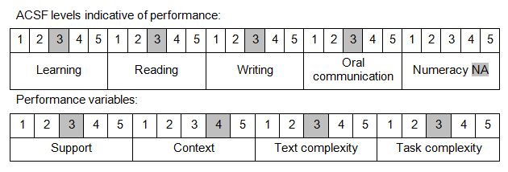

Further information on ACSF and the foundation skills underpinning this unit can be found in the Foundation Skills Guide on the GSA website.

Unit Mapping Information
This unit supersedes and is equivalent to NWP202B Apply environmental and licensing procedures.

Links
Companion Volume implementation guides are found in VETNet - https://vetnet.education.gov.au/Pages/TrainingDocs.aspx?q=26336bc0-04e5-49d9-8c31-46c49b6a0037
Companion Volume implementation guides are found in VETNet - https://vetnet.education.gov.au/Pages/TrainingDocs.aspx?q=26336bc0-04e5-49d9-8c31-46c49b6a0037
Companion Volume implementation guides are found in VETNet - https://vetnet.education.gov.au/Pages/TrainingDocs.aspx?q=26336bc0-04e5-49d9-8c31-46c49b6a0037
Companion Volume implementation guides are found in VETNet - https://vetnet.education.gov.au/Pages/TrainingDocs.aspx?q=26336bc0-04e5-49d9-8c31-46c49b6a0037

