NWPGEN002 Ensure compliance with water industry standards, guidelines and legislation
Release: 1

NWPGEN002 Ensure compliance with water industry standards, guidelines and legislation

Modification History
Release | Comments
1 | This unit was released in NWP Water Training Package release 1.0 and meets the Standards for Training Packages.  - New unit  - Created drawing upon information from deleted unit NWP702A

Application
This unit describes the skills required to ensure compliance with the risk management principles established in the Australian Drinking Water Guidelines (ADWG), Australian Sewage Quality Management Guidelines and Australian Guidelines for Water Recycling (AGWR) which contribute to the improved management of water supply systems and the reduction of water quality risks for water supplies.
This unit applies to those working in all roles in the water industry.
The skills and knowledge described in this unit must be applied within the legislative, regulatory and policy environment in which they are carried out. Organisational policies and procedures must be consulted and adhered to.
Those undertaking this unit would mostly work independently, with supervision responsibilities, while performing complex tasks in a range of contexts.
No licensing, legislative or certification requirements apply to unit at the time of publication.

Competency Field
General

Elements and Performance Criteria
ELEMENTS | PERFORMANCE CRITERIA
Elements describe the essential outcomes | Performance criteria describe the performance needed to demonstrate achievement of the element. Where bold italicised text is used, further information is detailed in the range of conditions section.
1. Interpret key legislation and guidelines of the water industry | 1.1 Access and interpret the relevant guidelines and legislative requirements.  1.2 Analyse the key features or elements.  1.3 Establish the relationships between the guidelines and the state and territory requirements.
2. Lead compliance with legislation and reporting function | 2.1 Interpret organisation standards and processes for reporting compliance with legislative requirements.  2.2 Integrate legislative requirements into organisation water quality management plan.  2.3 Provide advice on the links between the regulatory framework and work practices.  2.4 Convey importance of multiple barrier principles and their general function to team members.  2.5 Manage risks utilising the organisation’s risk management principles.  2.6 Collate relevant collected data to support compliance and review for completeness and accuracy.  2.7 Refine and disseminate compliance reporting procedures.
3. Communicate compliance with legislation to team members | 3.1 Establish steps to monitor compliance and reporting function.  3.2 Address identified areas of non-compliance and take corrective action.  3.3 Provide feedback on compliance issues to team members.  3.4 Make recommendation for preventative measures.  3.5 Drive continuous improvement of work practices to achieve water quality outcomes.

Foundation Skills
The foundation skills demands of this unit have been mapped for alignment with the Australian Core Skills Framework (ACSF). The following tables outline the performance levels indicated for successful attainment of the unit.

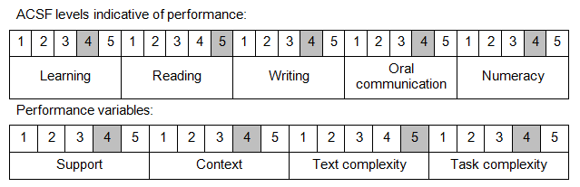

Further information on ACSF and the foundation skills underpinning this unit can be found in the Foundation Skills Guide on the GSA website.

Range of Conditions
Guidelines include: | - ADWG (Australian Drinking Water Guidelines)  - Australian Sewage Quality Management Guidelines  - AGWR (Australian Guidelines for Water Recycling)

Unit Mapping Information
No equivalent unit.

Links
Companion Volume implementation guides are found in VETNet - https://vetnet.gov.au/Pages/TrainingDocs.aspx?q=26336bc0-04e5-49d9-8c31-46c49b6a0037
Companion Volume implementation guides are found in VETNet - https://vetnet.gov.au/Pages/TrainingDocs.aspx?q=26336bc0-04e5-49d9-8c31-46c49b6a0037
Companion Volume implementation guides are found in VETNet - https://vetnet.gov.au/Pages/TrainingDocs.aspx?q=26336bc0-04e5-49d9-8c31-46c49b6a0037
Companion Volume implementation guides are found in VETNet - https://vetnet.gov.au/Pages/TrainingDocs.aspx?q=26336bc0-04e5-49d9-8c31-46c49b6a0037

