NWPGEN001 Apply the risk management principles of the water industry standards, guidelines and legislation
Release: 1

NWPGEN001 Apply the risk management principles of the water industry standards, guidelines and legislation

Modification History
Release | Comments
1 | This unit was released in NWP Water Training Package release 1.0 and meets the Standards for Training Packages.  - New unit  - Created drawing upon information from deleted unit NWP279

Application
This unit describes the skills required to comply with the knowledge of risk management principles established in the Australian Drinking Water Guidelines (ADWG) and the Australian Guidelines for Water Recycling (AGWR), which contribute to the improved management of water supply systems and the reduction of water quality risks for water supplies.
This unit applies to those working in all roles in the water industry.
The skills and knowledge described in this unit must be applied within the legislative, regulatory and policy environment in which they are carried out. Organisational policies and procedures must be consulted and adhered to.
Those undertaking this unit would work under supervision, while performing routine tasks in a range of contexts.
No licensing, legislative or certification requirements apply to unit at the time of publication.

Competency Field
General

Elements and Performance Criteria
ELEMENTS | PERFORMANCE CRITERIA
Elements describe the essential outcomes | Performance criteria describe the performance needed to demonstrate achievement of the element. Where bold italicised text is used, further information is detailed in the range of conditions section.
1. Identify relevant guidelines of the water industry | 1.1 Identify the relevant guidelines and legislative requirements.  1.2 Identify the key features or elements.  1.3 Outline the relationships between the guidelines and the state and territory requirements.
2. Describe the risk management principles for the control of contaminants in the water cycle | 2.1 Outline multiple barrier principles and their general function.  2.2 Identify relevant risks and hazards utilising the organisation’s risk management principles.  2.3 Identify the main components of organisation water systems.
3. Apply principles to work context | 3.1 List the requirements for the organisation water quality management plan.  3.2 Identify the links between the regulatory framework and work practices.  3.3 Apply the principles to daily work practices.
4. Review and evaluate water quality management principles | 4.1 Evaluate records of water quality incidents and identify potential improvement of application of guidelines.  4.2 Participate in continuous improvement of work practices to achieve water quality outcomes.

Foundation Skills
The foundation skills demands of this unit have been mapped for alignment with the Australian Core Skills Framework (ACSF). The following tables outline the performance levels indicated for successful attainment of the unit.

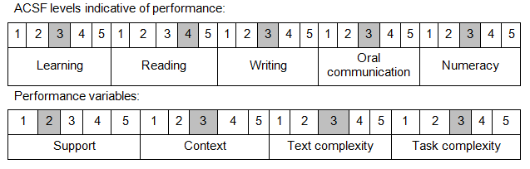

Further information on ACSF and the foundation skills underpinning this unit can be found in the Foundation Skills Guide on the GSA website.

Range of Conditions
Guidelines include: | - ADWG (Australian Drinking Water Guidelines)  - AGWR (Australian Guidelines for Water Recycling)

Unit Mapping Information
No equivalent unit.

Links
Companion Volume implementation guides are found in VETNet - https://vetnet.education.gov.au/Pages/TrainingDocs.aspx?q=26336bc0-04e5-49d9-8c31-46c49b6a0037
Companion Volume implementation guides are found in VETNet - https://vetnet.education.gov.au/Pages/TrainingDocs.aspx?q=26336bc0-04e5-49d9-8c31-46c49b6a0037
Companion Volume implementation guides are found in VETNet - https://vetnet.education.gov.au/Pages/TrainingDocs.aspx?q=26336bc0-04e5-49d9-8c31-46c49b6a0037
Companion Volume implementation guides are found in VETNet - https://vetnet.education.gov.au/Pages/TrainingDocs.aspx?q=26336bc0-04e5-49d9-8c31-46c49b6a0037

