NWP50715 Diploma of Water Industry Operations
Release 1

NWP50715 Diploma of Water Industry Operations

Modification History
Release | Comments
1 | This qualification was released in NWP Water Training Package release 1.0 and meets the Standards for Training Packages.  - New qualification. Streams developed to better reflect occupational outcomes.

Qualification Description
This qualification allows for the attainment of general competencies in water industry operations or specialisation in hydrography, irrigation or trade waste.

The general qualification covers the competencies for those who require a broad range of skills. It allows experienced staff to reflect advanced practice and develop greater team leadership roles.

The hydrography specialisation covers the skills required to measure, collect and analyse hydrometric information and review the accumulated data to develop water management plans for inland water systems including rivers, lakes, stormwater and sewage.

The irrigation specialisation covers the skills required to coordinate and manage the development, implementation and review of irrigation plans and systems.

The trade waste specialisation covers the skills required to coordinate and manage the development, implementation and review of trade waste programs.

No licensing, legislative or certification requirements apply to this qualification at the time of publication.

Additional qualification advice
Where a defined specialisation is completed as listed below, the resultant testamur can be titled: Diploma of Water Industry Operations (field of study) e.g. Diploma of Water Industry Operations (Hydrography).

Packaging Rules
9 units of competency are required for this qualification:
- 2 core units
- 7 elective units

Specialisation
The candidate may complete either the general qualification or specialise in hydrography, irrigation or trade waste by selecting elective units as specified in the table below.
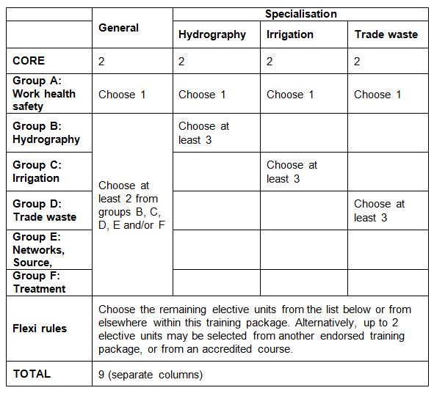
All elective units selected from outside this qualification must reflect the occupational and learning outcomes of this AQF qualification level. Seek further advice on selecting imported units of competency in the NWP Implementation Guide.

Where a prerequisite unit is attached to an elective unit it is identified by this symbol ∟.

The prerequisite units attached to any of the elective units must be undertaken and are additional to the number of elective units required for the qualification.

Elective units selected must not duplicate content already covered by other units in this qualification.
Core units
NWPGEN002 | Ensure compliance with water industry guidelines, standards and legislation
NWPGEN006 | Implement and manage environmental management policies, plans, procedures and programs
Group A: Work health safety
BSBWHS501 | Ensure a safe workplace
BSBWHS502 | Manage effective WHS consultation and participation processes
BSBWHS503 | Contribute to the systematic management of WHS risk
BSBWHS504 | Manage WHS hazards and risks
BSBWHS505 | Investigate WHS incidents
Group B: Hydrography
NWPHYD001 | Apply principles of open channel hydraulics
NWPHYD011 | Measure and process low and medium flows using area velocity methods
NWPHYD015 | Undertake surveying of monitoring sites
NWPHYD016 | Process and report hydrometric time series data
NWPHYD017 | Develop and maintain ratings
NWPHYD018 | Plan water resource management
MSL976003A | Evaluate and select appropriate test methods and/or procedures
Group C: Irrigation
NWPIRR061 | Develop and review groundwater management plan
NWPIRR062 | Develop and review irrigation system management plan
NWPIRR063 | Develop and review surface water management plan
NWPIRR071 | Implement and coordinate irrigation delivery systems
NWPIRR072 | Implement and coordinate surface water management plan
NWPIRR073 | Implement and coordinate catchment management plan
NWPIRR074 | Implement and coordinate groundwater management plan
Group D: Trade waste
NWPTRD002 | Evaluate, implement and monitor high risk trade waste discharge approvals
NWPTRD021 | Implement and manage trade waste policies and plans
NWPTRD022 | Develop and modify trade waste policies and plans
NWPTRD024 | Establish connections of water and wastewater systems
NWPGEN014 | Sampling and testing trade wastewater
AHCLPW306A | Undertake sampling and testing of water
Group E: Networks and Source
NWPNET033 | Coordinate and monitor water asset construction
NWPNET034 | Conduct commissioning and post-commissioning activities
NWPSOU028 | Prepare and report on data related to flood operations
Group F: Treatment
NWPTRT011 | Assess and improve chemical dosing process
NWPTRT085 | Assess and improve wastewater processes to control microbial impacts
Group G: General elective units
BSBFIM501 | Manage budgets and financial plans
BSBLED401 | Develop teams and individuals
BSBMGT502 | Manage people performance
BSBMGT516 | Facilitate continuous improvement
BSBMGT517 | Manage operational plan
BSBPMG522 | Undertake project work
BSBSMB407 | Manage a small team
BSBWRT401 | Write complex documents
CHCCOM003 | Develop workplace communication strategies
CHCORG627B | Provide mentoring support to colleagues
CPPSIS4022A | Store and retrieve spatial data
CPPSIS5032A | Capture new spatial data
CPPSIS5040A | Collate and interpret spatial data
FSKNUM27 | Collect, organise and interpret statistical data for work
LGAWORK501A | Prepare preliminary design for operational works
LGAWORK502A | Prepare detailed works project documentation
LGAWORK503A | Undertake project investigation
MEM30001A | Use computer aided drafting systems to produce basic engineering drawings  ∟MEM16006A Organise and communicate information  ∟MEM16008A Interact with computing technology
MSL936002A | Conduct an internal audit of the quality system
PMAOMIR512B | Establish incident response preparedness and response systems
PSPPROC506A | Plan to manage contract
TAEASS301B | Contribute to assessment
TAEDEL402A | Plan, organise and facilitate learning in the workplace
TAEDEL404A | Mentor in the workplace

Qualification Mapping Information
No equivalent qualification.

Links
GSA website - http://www.govskills.com.au
NWP Implementation Guide - http://www.govskills.com.au/guides/water/implementation-guide
NWP Assessment Guide - http://www.govskills.com.au/guides/water/assessment-guide
NWP Foundation Skills Guide - http://www.govskills.com.au/guides/water/foundation-skills-guide
NWP Knowledge Guide - http://www.govskills.com.au/guides/water/knowledge-guide

