NWP40615 Certificate IV in Water Industry Treatment
Release 2

NWP40615 Certificate IV in Water Industry Treatment

Modification History
Release 2: This is the second release of this qualification in NWP Water Training Package with updated codes and details.
Release 1: This qualification was released in NWP Water Training Package release 1.0 and meets the Standards for Training Packages.
- New qualification. Streams developed to better reflect occupational outcomes.

Qualification Description
This qualification allows for the attainment of general competencies in water industry treatment or specialisation in drinking water or wastewater.
The general qualification covers the skills for those who have supervisory responsibility and require a broad range of skills within treatment operations.
The drinking water specialisation covers skills required to assess and improve the processes within a drinking water treatment plant.
The wastewater specialisation covers skills required to assess and improve the processes within a drinking water treatment plant.
No licensing, legislative or certification requirements apply to this qualification at the time of publication.
Additional qualification advice
Where a defined specialisation is completed as listed below, the resultant testamur can be titled: Certificate IV in Water Industry Treatment (field of study) e.g. Certificate IV in Water Industry Treatment (Drinking water).

Entry Requirements
There are no entry requirements for this qualification.

Packaging Rules
10 units of competency are required for this qualification:
• 2 core units
• 8 elective units
The candidate may complete either the general qualification or specialise in drinking water or wastewater by selecting elective units as specified in the table below.

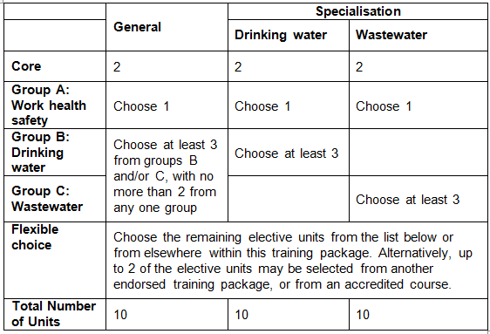
All elective units selected from outside this qualification must reflect the occupational and learning outcomes of this AQF qualification level. Seek further advice on selecting imported units of competency in the NWP Implementation Guide.
Elective units selected must not duplicate content already covered by other units in this qualification.
Core units
NWPGEN002 | Ensure compliance with water industry standards, guidelines and legislation
NWPGEN005 | Coordinate and monitor the application of environmental plans and procedures
Group A: Work health safety
BSBWHS401 | Implement and monitor WHS policies, procedures and programs to meet legislative requirements
BSBWHS412 | Assist with workplace compliance with WHS laws
BSBWHS413 | Contribute to implementation and maintenance of WHS consultation and participation processes
BSBWHS414 | Contribute to WHS risk management
Group B: Drinking water
NWPGEN010 | Contribute to the continuous improvement of quality systems
NWPGEN025 | Apply principles of chemistry to water systems and processes
NWPTRT011 | Assess and improve chemical dosing process
NWPTRT032 | Assess and improve sedimentation processes
NWPTRT042 | Assess and improve granular media filters
NWPTRT045 | Assess and improve desalination processes
NWPTRT051 | Assess and improve treatment for pathogen removal
NWPTRT085 | Assess and improve wastewater processes to control microbial impacts
Group C: Wastewater
NWPGEN010 | Contribute to the continuous improvement of quality systems
NWPGEN025 | Apply principles of chemistry to water systems and processes
NWPTRT011 | Assess and improve chemical dosing process
NWPTRT032 | Assess and improve sedimentation processes
NWPTRT042 | Assess and improve granular media filters
NWPTRT045 | Assess and improve desalination processes
NWPTRT051 | Assess and improve treatment for pathogen removal
NWPTRT084 | Assess and improve activated sludge and nutrient removal processes
NWPTRT085 | Assess and improve wastewater processes to control microbial impacts
NWPTRT093 | Assess and improve anaerobic digestion processes
General elective units
AHCBUS515 | Prepare estimates, quotes and tenders
BSBCUS401 | Coordinate implementation of customer service strategies
BSBFLM312 | Contribute to team effectiveness
BSBINM301 | Organise workplace information
BSBLDR403 | Lead team effectiveness
BSBMGT402 | Implement operational plan
BSBSMB407 | Manage a small team
BSBWHS520 | Manage implementation of emergency procedures
BSBWOR404 | Develop work priorities
BSBWRT401 | Write complex documents
MSS404061 | Facilitate the use of SCADA systems in a team or work area
NWPGEN010 | Contribute to the continuous improvement of quality systems
NWPNET033 | Coordinate and monitor water asset construction
TAEDEL301 | Provide work skill instruction

Qualification Mapping Information
No equivalent qualification.

Links
Companion Volume implementation guides are found in VETNet - https://vetnet.gov.au/Pages/TrainingDocs.aspx?q=26336bc0-04e5-49d9-8c31-46c49b6a0037

