NWP40515 Certificate IV in Water Industry Operations
Release 2

NWP40515 Certificate IV in Water Industry Operations

Modification History
Release 2: This is the second release of this qualification in NWP Water Training Package with updated unit codes and details.
Release 1: This qualification was released in NWP Water Training Package release 1.0 and meets the Standards for Training Packages.
- New qualification. Streams developed to better reflect occupational outcomes.

Qualification Description
This qualification allows for the attainment of general competencies in water industry operations or specialisation in networks, source, hydrography, irrigation or trade waste.
The general qualification covers the skills for those who have supervisory responsibility and require a broad range of skills.
The networks specialisation covers the skills required to operate, construct, and maintain water and wastewater networks
The source specialisation covers the skills required to monitor and operate catchment, weirs, locks, dams, rivers, reservoirs, bulk water and groundwater management and implement operational and safety plans.
The hydrography specialisation covers the skills required to measure, collect and analyse hydrometric information and review the accumulated data to develop water management plans for inland water systems including rivers, lakes, stormwater and sewage.
The irrigation specialisation covers the skills required to coordinate and monitor the operation of irrigation systems.
The trade waste specialisation covers the competencies in compliance, licencing and regulations of trade waste management.
No licensing, legislative or certification requirements apply to this qualification at the time of publication.
Additional qualification advice
Where a defined specialisation is completed as listed below, the resultant testamur can be titled: Certificate IV in Water Industry Operations (field of study) e.g. Certificate IV in Water Industry Operations (Networks).

Entry Requirements
There are no entry requirements for this qualification.

Packaging Rules
11 units of competency are required for this qualification:
No equivalent qualification.
• 2 core units
• 9 elective units
Specialisation
The candidate may complete either the general qualification or specialise in networks, source, hydrography, irrigation or trade waste by selecting elective units as specified in the table below.
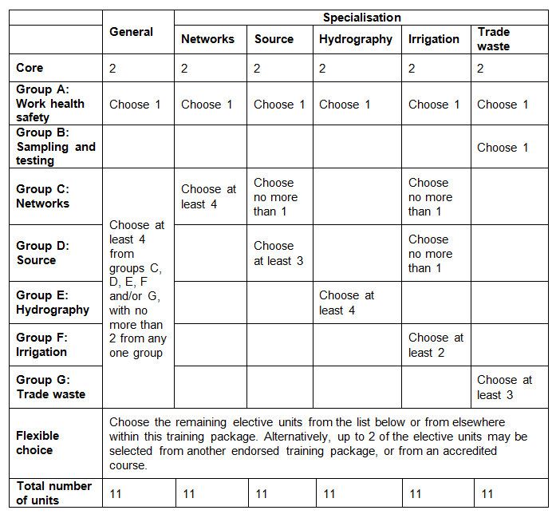
All elective units selected from outside this qualification must reflect the occupational and learning outcomes of this AQF qualification level. Seek further advice on selecting imported units of competency in the NWP Implementation Guide.
Elective units selected must not duplicate content already covered by other units in this qualification.
Core units
NWPGEN002 | Ensure compliance with water industry standards, guidelines and legislation
NWPGEN005 | Coordinate and monitor the application of environmental plans and procedures
Group A: Work health safety
BSBWHS401 | Implement and monitor WHS policies, procedures and programs to meet legislative requirements
BSBWHS412 | Assist with workplace compliance with WHS laws
BSBWHS413 | Contribute to implementation and maintenance of WHS consultation and participation processes
BSBWHS414 | Contribute to WHS risk management
Group B: Sampling and testing
AHCLPW306 | Undertake sampling and testing of water
NWPCAD001 | Respond to blue-green algae outbreaks
NWPGEN014 | Sampling and testing trade wastewater
NWPGEN022 | Perform laboratory testing
Group C: Networks
BSBCUS401 | Coordinate implementation of customer service strategies
BSBWOR404 | Develop work priorities
NWPGEN015 | Develop an operation plan
NWPHYD014 | Measure and process medium and high flows using a range of methods and equipment
NWPIRR033 | Coordinate and monitor the operation of irrigation delivery systems
NWPIRR035 | Coordinate and monitor the operation of drainage systems
NWPNET005 | Optimise network systems
NWPNET017 | Supervise and report on conduit inspections
NWPNET019 | Prepare and restore worksite
NWPNET025 | Coordinate and manage maintenance and repair of network assets
NWPNET033 | Coordinate and monitor water asset construction
Group D: Source
BSBMGT402 | Implement operational plan
BSBSMB407 | Manage a small team
NWPCAD014 | Inspect and report river performance
NWPSOU014 | Develop and implement catchment operations plans
NWPSOU026 | Implement dam safety plans
NWPSOU041 | Coordinate and monitor bulkwater system operations
NWPSOU053 | Coordinate and monitor groundwater system usage
Group E: Hydrography
AHCLPW306 | Undertake sampling and testing of water
FSKNUM021 | Apply an expanding range of arithmetical calculations for work
MSL924003 | Process and interpret data
NWPGEN022 | Perform laboratory testing
NWPHYD011 | Measure and process low and medium flows using area velocity methods
NWPHYD013 | Operate, maintain and decommission monitoring sites
NWPHYD014 | Measure and process medium and high flows using a range of methods and equipment
NWPHYD015 | Undertake surveying of monitoring sites
NWPSOU053 | Coordinate and monitor groundwater system usage
Group F: Irrigation
NWPCAD014 | Inspect and report river performance
NWPGEN027 | Monitor and operate pump stations
NWPIRR033 | Coordinate and monitor the operation of irrigation delivery systems
NWPIRR034 | Coordinate and monitor surface water systems
NWPIRR035 | Coordinate and monitor the operation of drainage systems
NWPNET033 | Coordinate and monitor water asset construction
NWPSOU041 | Coordinate and monitor bulkwater system operations
Group G: Trade waste
NWPCAD003 | Identify and confirm blue-green algae outbreaks
NWPGEN028 | Investigate and report on breaches of water industry legislation
NWPTRD001 | Evaluate, implement and monitor standard low risk trade waste discharge approvals
NWPTRD012 | Investigate, rectify and report on trade waste incidents
NWPTRD023 | Coordinate, implement and report trade waste monitoring procedures
NWPTRD024 | Establish connections of water and wastewater systems
General elective units
AHCBUS515 | Prepare estimates, quotes and tenders
BSBCUS401 | Coordinate implementation of customer service strategies
BSBLDR403 | Lead team effectiveness
BSBMGT402 | Implement operational plan
BSBSMB407 | Manage a small team
BSBWOR404 | Develop work priorities
BSBWRT401 | Write complex documents
NWPGEN010 | Contribute to continuous improvement of quality systems
NWPGEN025 | Apply principles of chemistry to water systems and processes
NWPTRT051 | Assess and improve treatment for pathogen removal
RIIWHS202D | Enter and work in confined spaces
TAEDEL301 | Provide work skill instruction

Qualification Mapping Information
No equivalent qualification.

Links
Companion Volume implementation guides are found in VETNet - https://vetnet.gov.au/Pages/TrainingDocs.aspx?q=26336bc0-04e5-49d9-8c31-46c49b6a0037

