NWP30315 Certificate III in Water Industry Treatment
Release 1

NWP30315 Certificate III in Water Industry Treatment

Modification History
Release | Comments
1 | This qualification was released in NWP Water Training Package release 1.0 and meets the Standards for Training Packages.  - New qualification. Streams developed to better reflect occupational outcomes.

Qualification Description
This qualification allows for the attainment of general competencies in water industry treatment or specialisation in drinking water or wastewater.

The general qualification reflects the skills required to conduct treatment for drinking water, wastewater and recycled water.

The drinking water specialisation covers skills required to monitor, operate and control treatment processes within a drinking water plant.

The wastewater specialisation covers skills required to monitor, operate and control treatment processes within a wastewater treatment plant.

No licensing, legislative or certification requirements apply to this qualification at the time of publication.

Additional qualification advice
Where a defined specialisation is completed as listed below, the resultant testamur can be titled: Certificate III in Water Industry Treatment (field of study) e.g. Certificate III in Water Industry Treatment (Drinking water).

Packaging Rules
11 units of competency are required for this qualification:
- 2 core units
- 9 elective units

Specialisation
The candidate may complete either the general qualification or specialise in drinking water or wastewater by selecting elective units as specified in the table below.
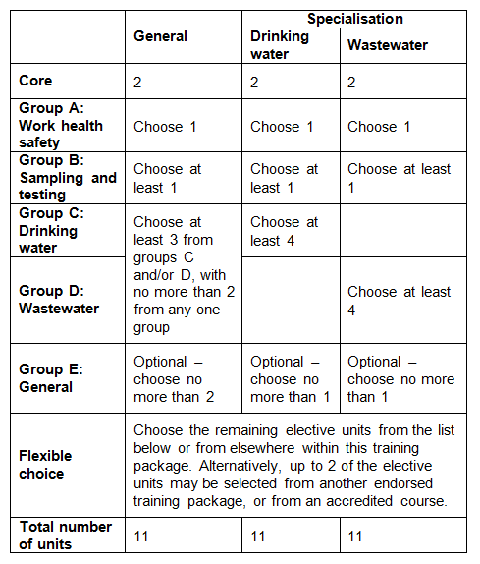
Choose the remaining elective units from the list below or from elsewhere within this training package. Alternatively, 2 elective units may be selected from another endorsed training package, or from an accredited course.

All elective units selected from outside this qualification must reflect the occupational and learning outcomes of this AQF qualification level. Seek further advice on selecting imported units of competency in the NWP Implementation Guide.
Elective units selected must not duplicate content already covered by other units in this qualification.
Core units
NWPGEN001 | Apply the risk management principles of the water industry standards, guidelines and legislation
NWPGEN004 | Assess, implement and report environmental procedures
Group A: Work health safety
AHCCHM101A | Follow basic chemical safety rules
BSBWHS301 | Maintain workplace safety
BSBWHS302 | Apply knowledge of WHS legislation in the workplace
BSBWHS303 | Participate in WHS hazard identification, risk assessment and risk control
BSBWHS304 | Participate effectively in WHS communication and consultation processes
Group B: Sampling and testing
NWPGEN007 | Sample and test drinking water
NWPGEN008 | Sample and test wastewater
NWPSOU001 | Respond to blue-green algae outbreaks
NWPSOU003 | Identify and confirm blue-green algae
Group C: Drinking water
NWPTRT014 | Operate and control iron and manganese removal process
NWPTRT015 | Operate and control coagulation and flocculation processes
NWPTRT031 | Operate and control sedimentation and clarification processes
NWPTRT033 | Operate and control DAF processes
NWPTRT034 | Operate and control activated carbon processes
NWPTRT035 | Operate and control ion exchange and softening processes
NWPTRT041 | Operate and control granular media filters
NWPTRT043 | Operate and control membrane filters
NWPTRT044 | Operate and control desalination processes
NWPTRT054 | Operate and control chloramination processes
NWPTRT091 | Operate and control solids handling processes
NWPGEN009 | Perform complex testing
NWPSOU001 | Respond to blue green algae outbreaks
Group D: Wastewater
NWPTRT033 | Operate and control DAF processes
NWPTRT041 | Operate and control granular media filters
NWPTRT043 | Operate and control membrane filters
NWPTRT054 | Operate and control chloramination processes
NWPTRT062 | Operate and control reclaimed water irrigation
NWPTRT072 | Operate and control odour removal processes
NWPTRT081 | Operate and control activated sludge processes
NWPTRT082 | Operate and control nutrient removal processes
NWPTRT083 | Operate and control aerobic bioreactor processes
NWPTRT091 | Operate and control solids handling processes
NWPTRT092 | Operate and control digestion processes
NWPTRT094 | Operate and control incineration processes
NWPTRT101 | Operate and control lagoon processes
NWPGEN009 | Perform complex testing
NWPSOU001 | Respond to blue green algae outbreaks
Group E: General elective units
NWPTRT012 | Operate and control fluoride addition process
NWPTRT053 | Operate and control UV processes
CPCCCM1015A | Carry out measurements and calculations
RIISAM204D | Operate small plant and equipment
BSBCMM301 | Process customer complaints
BSBCUS301 | Deliver and monitor a service to customers
BSBFLM305 | Support operational plan
BSBFLM312 | Contribute to team effectiveness
FSKNUM21 | Apply an expanding range of mathematical calculations for work
MSAPMOHS216A | Operate breathing apparatus
RIIWHS202D | Enter and work in confined spaces
RIIWHS302D | Implement traffic management plan
TLID2003A | Handle dangerous goods/hazardous substances

Qualification Mapping Information
No equivalent qualification.

Links
GSA website - http://www.govskills.com.au
NWP Implementation Guide - http://www.govskills.com.au/guides/water/implementation-guide
NWP Assessment Guide - http://www.govskills.com.au/guides/water/assessment-guide
NWP Foundation Skills Guide - http://www.govskills.com.au/guides/water/foundation-skills-guide
NWP Knowledge Guide - http://www.govskills.com.au/guides/water/knowledge-guide

