NWP30215 Certificate III in Water Industry Operations
Release: 1

NWP30215 Certificate III in Water Industry Operations

Modification History
Release | Comments
1 | This qualification was released in NWP Water Training Package release 1.0 and meets the Standards for Training Packages.  - New qualification. Streams developed to better reflect occupational outcomes.

Qualification Description
This qualification allows for the attainment of general competencies in water industry operations or specialisation in networks, source, irrigation or treatment.

The general qualification covers the skills required to operate in a broad range of water operations.

The networks specialisation covers the skills required to monitor, operate and maintain network operations.

The source specialisation covers the skills required to monitor, operate and maintain source operations.

The hydrography specialisation covers the skills required to monitor, operate and maintain hydrography operations.

No licensing, legislative or certification requirements apply to this qualification at the time of publication.

Additional qualification advice
Where a defined specialisation is completed as listed below, the resultant testamur can be titled: Certificate III in Water Industry Operations (field of study) e.g. Certificate III in Water Industry Operations (Networks).

Packaging Rules
11 units of competency are required for this qualification:
- 2 core units
- 9 elective units

Specialisation
The candidate may complete either the general qualification or specialise in networks, source or hydrography by selecting elective units as specified in the table below.
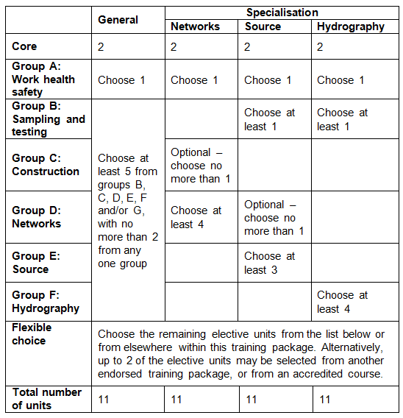
All elective units selected from outside this qualification must reflect the occupational and learning outcomes of this AQF qualification level. Seek further advice on selecting imported units of competency in the NWP Implementation Guide.

Where a prerequisite unit is attached to an elective unit it is identified by this symbol ∟.

The prerequisite units attached to any of the elective units must be undertaken and are additional to the number of elective units required for the qualification.

Elective units selected must not duplicate content already covered by other units in this qualification.
Core units
NWPGEN001 | Apply the risk management principles of the water industry standards, guidelines and legislation
NWPGEN004 | Assess, implement and report environmental procedures
Group A: Work health safety
BSBWHS301 | Maintain workplace safety
BSBWHS302 | Apply knowledge of WHS legislation in the workplace
BSBWHS303 | Participate in WHS hazard identification, risk assessment and risk control
BSBWHS304 | Participate effectively in WHS communication and consultation processes
Group B: Sampling and testing
NWPGEN007 | Sample and test drinking water
NWPGEN008 | Sample and test wastewater
NWPGEN009 | Perform complex testing
NWPSOU001 | Respond to blue-green algae outbreaks
NWPSOU003 | Identify and confirm blue-green algae
AHCLPW306A | Undertake sampling and testing of water
Group C: Construction
CPCCCM2004A | Handle construction materials  ∟ CPCCOHS2001A Apply OHS requirements, policies and procedures in the construction industry
RIICRC202D | Install signs
CPCCCM2003B | Calculate and cost construction work
PMBWELD301B | Butt weld polyethylene plastic pipelines
PMBWELD302B | Electrofusion weld polyethylene pipelines
PMBWELD305B | Install polyethylene plastic pressure pipelines
PMBWELD308B | Install PVC plastic pressure pipelines
RIICBS310D | Conduct patching operations
RIICCM205D | Carry out manual excavation
RIICCM207D | Spread and compact materials manually
RIICCM208D | Carry out basic levelling
RIICCM209D | Carry out concrete work
RIICCM210D | Install trench support
RIICCM211D | Erect and dismantle temporary fencing and gates
RIICCM301D | Construct and dismantle fences and gates
RIICPL304D | Install pre-cast gully pits
RIICPL305D | Install pre-cast access chambers
RIICRC303D | Lay pavers
RIICRC314D | Handle concrete materials
RIICRC315D | Use concreting materials and equipment
RIICRC323D | Insert tie bars in fresh concrete
RIICWM501D | Implement civil construction plan
RIIHAN211D | Conduct basic scaffolding operations
RIIMPO327D | Conduct pipe layer operations
RIISAM203D | Use hand and power tools
RIISAM204D | Operate small plant and equipment
RIIWHS202D | Enter and work in confined spaces
RIIWHS204D | Work safely at heights
RIIWMG203D | Drain and dewater civil construction site
Group D: Networks
NWPNET001 | Disinfect networks assets
NWPNET003 | Control electrical risk on metallic pipes
NWPNET012 | Use locating devices
NWPNET013 | Identify and respond to water problems
NWPNET014 | Perform odour and infiltration investigations
NWPNET015 | Perform leak detection
NWPNET016 | Inspect sewer or stormwater line
NWPNET026 | Inspect, maintain and repair hydrants
NWPNET027 | Monitor and control vacuum sewer system
NWPNET041 | Monitor and operate water distribution systems
NWPNET042 | Monitor and operate wastewater collection and transfer systems
NWPNET043 | Monitor and operate bulkwater transfer systems
NWPNET044 | Test and commission water distribution systems
NWPNET045 | Test and commission wastewater collection systems
NWPIRR003 | Inspect and operate surface water systems
NWPIRR014 | Install meters for rural water supplies
NWPIRR022 | Maintain meters for rural water supplies
RIISAM203D | Use hand and power tools
RIICCM205D | Carry out manual excavation
RIICCM209D | Carry out concrete work
RIICCM210D | Install trench support
RIICWM501D | Implement civil construction plan
RIIMPO327D | Conduct pipe layer operations
Group E: Source
NWPSOU013 | Monitor and coordinate catchment operations
NWPSOU022 | Monitor and control dam operations
NWPSOU023 | Monitor and implement dam maintenance
NWPSOU024 | Inspect and report on concrete dam safety
NWPSOU025 | Inspect and report on embankment dam safety
NWPSOU027 | Route floods through storages
NWPSOU029 | Conduct and report dam safety instrumentation monitoring
NWPSOU030 | Inspect and report river performance
NWPSOU031 | Operate and maintain locks and weirs
NWPSOU032 | Operate and maintain fishways
NWPSOU033 | Operate and maintain salt interception works
NWPSOU052 | Inspect and operate groundwater regulation
NWPNET043 | Monitor and operate bulkwater transfer systems
Group F: Hydrography
NWPHYD011 | Measure and process low and medium flows using area velocity methods
NWPHYD012 | Establish monitoring sites
NWPGEN012 | Support the role and functions of the water industry
FSKNUM21 | Apply an expanding range of mathematical calculations for work
MSL904001A | Perform standard calibrations
MSL922001A | Record and present data
Group G: General elective units
NWPGEN013 | Apply principles of chemistry to water systems and processes
NWPIRR051 | Provide and promote customer service
NWPTRD011 | Investigate and report breaches of water industry legislation
NWPTRT001 | Operate and control water treatment processes
NWPTRT061 | Operate and control wastewater processes
BSBCMM301 | Process customer complaints
BSBCUS301 | Deliver and monitor a service to customers
BSBFLM305 | Support operational plan
BSBFLM312 | Contribute to team effectiveness
BSBINM301 | Organise workplace information
BSBWOR301 | Organise personal work priorities and development
CPCPPS5024A | Conduct a water audit and identify water-saving initiatives
CPPHSA4003A | Assess household water use
MSS404061A | Facilitate the use of SCADA systems in a team or work area
RIIWHS302D | Implement traffic management plan
TLID2003A | Handle dangerous goods/hazardous substances

Qualification Mapping Information
No equivalent qualification.

Links
Companion Volume implementation guides are found in VETNet - https://vetnet.education.gov.au/Pages/TrainingDocs.aspx?q=26336bc0-04e5-49d9-8c31-46c49b6a0037
Companion Volume implementation guides are found in VETNet - https://vetnet.education.gov.au/Pages/TrainingDocs.aspx?q=26336bc0-04e5-49d9-8c31-46c49b6a0037
Companion Volume implementation guides are found in VETNet - https://vetnet.education.gov.au/Pages/TrainingDocs.aspx?q=26336bc0-04e5-49d9-8c31-46c49b6a0037
Companion Volume implementation guides are found in VETNet - https://vetnet.education.gov.au/Pages/TrainingDocs.aspx?q=26336bc0-04e5-49d9-8c31-46c49b6a0037
Companion Volume implementation guides are found in VETNet - https://vetnet.education.gov.au/Pages/TrainingDocs.aspx?q=26336bc0-04e5-49d9-8c31-46c49b6a0037

