NWP20115 Certificate II in Water Industry Operations
Release 1

NWP20115 Certificate II in Water Industry Operations

Modification History
Release | Comments
1 | This qualification was released in NWP Water Training Package release 1.0 and meets the Standards for Training Packages.  - New qualification. Streams developed to better reflect occupational outcomes.

Qualification Description
This qualification allows for the attainment of general competencies in water industry operations or specialisation in networks, source, irrigation or treatment.

The general qualification covers the skills required to assist in a broad range of water operations.

The networks specialisation covers the skills required to assist in network operations.

The source specialisation covers the skills required to assist in source operations.

The irrigation specialisation covers the skills required to assist in irrigation operations

The treatment specialisation covers the skills required to assist in monitoring, operating and controlling treatment processes.

No licensing, legislative or certification requirements apply to this qualification at the time of publication.

Additional qualification advice
Where a defined specialisation is completed as listed below, the resultant testamur can be titled: Certificate II in Water Industry Operations (field of study) e.g. Certificate II in Water Industry Operations (Networks).

Packaging Rules
11 units of competency are required for this qualification:
- 2 core units
- 9 elective units

Specialisation
The candidate may complete either the general qualification or specialise in networks, source, irrigation or treatment by selecting elective units as specified in the table below.
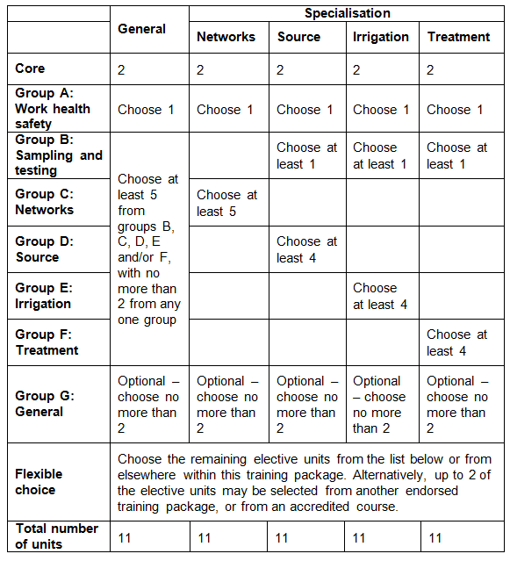
All elective units selected from outside this qualification must reflect the occupational and learning outcomes of this AQF qualification level. Seek further advice on selecting imported units of competency in the NWP Implementation Guide.

Where a prerequisite unit is attached to an elective unit it is identified by this symbol ∟.

The prerequisite units attached to any of the elective units must be undertaken and are additional to the number of elective units required for the qualification.

Elective units selected must not duplicate content already covered by other units in this qualification.
Core units
NWPGEN001 | Apply the risk management principles of the water industry standards, guidelines and legislation
NWPGEN003 | Apply the environmental and licensing procedures of the water industry
Group A: Work health safety
BSBWHS201 | Contribute to health and safety of self and others
BSBWHS301 | Maintain workplace safety
Group B: Sampling and testing
NWPGEN007 | Sample and test drinking water
NWPGEN008 | Sample and test wastewater
NWPSOU001 | Respond to blue-green algae outbreaks
Group C: Networks
NWPNET002 | Prepare and restore work site
NWPNET003 | Control electrical risk on metallic pipes
NWPNET004 | Monitor and operate network systems
NWPNET011 | Locate, identify and protect utilities
NWPNET021 | Install metering equipment
NWPNET022 | Maintain and repair networks assets for drinking water
NWPNET023 | Maintain and repair networks assets for wastewater
NWPNET024 | Maintain and repair network assets for bulkwater
NWPNET031 | Construct and install water distribution assets
NWPNET032 | Construct and install wastewater assets
NWPNET043 | Monitor and operate bulkwater transfer systems
NWPIRR001 | Monitor and operate irrigation and domestic delivery systems
NWPIRR002 | Operate basic flow control and regulating devices in irrigation systems
NWPIRR011 | Install devices for irrigation systems
NWPIRR012 | Construct open earthen channels and drains
NWPIRR013 | Construct and install irrigation delivery and stormwater drainage assets
NWPIRR021 | Maintain and repair irrigation channels and drains
RIICCM205D | Carry out manual excavation
RIIWHS202D | Enter and work in confined spaces
Group D: Source
NWPSOU002 | Control vegetation on a site
NWPSOU011 | Maintain catchment and surrounding areas
NWPSOU012 | Monitor, inspect and report catchment operations
NWPSOU021 | Inspect and maintain basic dams and water storages
NWPSOU051 | Monitor and operate groundwater extraction
NWPSOU054 | Monitor and operate pump stations
NWPNET022 | Maintain and repair networks assets for drinking water
NWPNET023 | Maintain and repair networks assets for wastewater
Group E: Irrigation
NWPIRR002 | Operate basic flow control and regulating devices in irrigation systems
NWPIRR012 | Construct open earthen channels and drains
NWPIRR013 | Construct and install irrigation delivery and stormwater drainage assets
NWPIRR021 | Maintain and repair irrigation channels and drains
NWPIRR041 | Identify and apply water entitlements and delivery processes
NWPNET004 | Monitor and operate network systems
NWPNET022 | Maintain and repair networks assets for water
NWPNET023 | Maintain and repair networks assets for wastewater
Group F: Treatment
NWPTRT001 | Operate and control water treatment processes
NWPTRT012 | Operate and control fluoride addition processes
NWPTRT013 | Operate and control liquefied chlorine gas disinfection processes
NWPTRT052 | Operate and control hypochlorite disinfection processes
NWPTRT053 | Operate and control UV processes
NWPTRT055 | Operate chlorine dioxide processes
NWPTRT056 | Operate and control ozone processes
NWPTRT061 | Operate and control wastewater processes
NWPTRT071 | Operate and control pre-treatment processes
NWPTRT073 | Operate and control wastewater sedimentation processes
NWPTRT101 | Operate and control lagoon processes
NWPGEN012 | Support the role and functions of the water industry
NWPSOU051 | Monitor and operate groundwater extraction
NWPSOU054 | Monitor and operate pump stations
Group G: General elective units
NWPGEN011 | Use maps, plans, drawings and specifications
NWPGEN012 | Support the role and functions of the water industry
NWPNET002 | Prepare and restore work site
CPCCCM1015A | Carry out measurements and calculations
RIISAM204D | Operate small plant and equipment
BSBCMM201 | Communicate in the workplace
BSBCUS201 | Deliver a service to customers
BSBWOR202 | Organise and complete daily work activities
FSKDIG03 | Use digital technology for routine workplace tasks
MSAPMOHS216A | Operate breathing apparatus
MSS404061A | Facilitate the use of SCADA systems in a team or work area
RIIWHS202D | Enter and work in confined spaces
RIIWHS302D | Implement traffic management plan
UEENEEK101A | Maintain safety and tidiness of remote area power supply systems  ∟UEENEEE101A Apply Occupational Health and Safety regulations, codes and practices in the workplace  ∟UEENEEK102A Work safely with remote area power supply systems  ∟UEENEE101A Apply Occupational Health and Safety regulations, codes and practices in the workplace
UEENEEK102A | Work safely with remote area power supply systems  ∟UEENEE101A Apply Occupational Health and Safety regulations, codes and practices in the workplace

Qualification Mapping Information
No equivalent qualification.

Links
GSA website - http://www.govskills.com.au
NWP Implementation Guide - http://www.govskills.com.au/guides/water/implementation-guide
NWP Assessment Guide - http://www.govskills.com.au/guides/water/assessment-guide
NWP Foundation Skills Guide - http://www.govskills.com.au/guides/water/foundation-skills-guide
NWP Knowledge Guide - http://www.govskills.com.au/guides/water/knowledge-guide

