DEFWHS017 Apply knowledge of WHS legislation
Release: 1

DEFWHS017 Apply knowledge of WHS legislation

Modification History
Release | Comments
1 | This unit was released in DEF Defence Training Package release 1.0 and meets the Standards for Training Packages.  This unit supersedes and is equivalent to DEFCP008 Apply knowledge of WHS legislation.  - Unit code updated  - Content and formatting updated to comply with the new standards  - All PC transitioned from passive to active voice

Application
This unit describes the skills required to analyse and apply knowledge of Work Health and Safety (WHS) legislation. The application of WHS legislation knowledge is specific to a variety of component processes in safety case activities.
This unit applies to those working in Defence who are not specialists in the field but need the knowledge to inform their decision making and underpins advice to stakeholders. This unit was developed for Defence workers involved in the evaluation and review of safety cases but is applicable to all individuals who work in this field.
The skills and knowledge described in this unit must be applied within the legislative, regulatory and policy environment in which they are carried out. Organisational policies and procedures must be consulted and adhered to.
Those undertaking this unit would work independently or as part of a team under indirect supervision. They must be able to use discretion and judgement and take responsibility for the quality of their outputs. They would perform complex tasks in a range of familiar contexts.
No licensing, legislative or certification requirements apply to unit at the time of publication.

Competency Field
Work Health & Safety

Elements and Performance Criteria
ELEMENTS | PERFORMANCE CRITERIA
Elements describe the essential outcomes | Performance criteria describe the performance needed to demonstrate achievement of the element. Where bold italicised text is used, further information is detailed in the range of conditions section.
1. Access and interpret relevant WHS legislation information | 1.1 Identify and obtain relevant WHS legislation requirements.  1.2 Analyse WHS legislation information obtained to determine the relevance and application to the organisation.  1.3 Formulate outcomes of the analysis and determine recommendations relevant to WHS legislation requirements.
2. Use knowledge of WHS legislation | 2.1 Apply WHS legislation requirements and recommendations relevant to safety cases.  2.2 Assess, review and record effectiveness of the recommendations.  2.3 Adjust recommendations if required and document for future application.

Foundation Skills
The foundation skills demands of this unit have been mapped for alignment with the Australian Core Skills Framework (ACSF). The following tables outline the performance levels indicated for successful attainment of the unit.
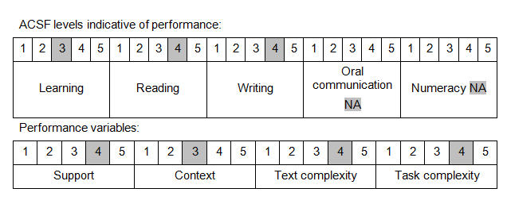

Further information on ACSF and the foundation skills underpinning this unit can be found in the Foundation Skills Guide on the GSA website.

Unit Mapping Information
This unit supersedes and is equivalent to DEFCP008 Apply knowledge of WHS legislation.

Links
Companion Volume implementation guides are found in VETNet - https://vetnet.gov.au/Pages/TrainingDocs.aspx?q=6bdbab1e-11ed-4bc9-9cba-9e1a55d4e4a9
Companion Volume implementation guides are found in VETNet - https://vetnet.gov.au/Pages/TrainingDocs.aspx?q=6bdbab1e-11ed-4bc9-9cba-9e1a55d4e4a9
Companion Volume implementation guides are found in VETNet - https://vetnet.gov.au/Pages/TrainingDocs.aspx?q=6bdbab1e-11ed-4bc9-9cba-9e1a55d4e4a9

