DEFWHS016 Conduct work health and safety inspections
Release: 1

DEFWHS016 Conduct work health and safety inspections

Modification History
Release | Comments
1 | This unit was released in DEF Defence Training Package release 1.0 and meets the Standards for Training Packages.  This unit supersedes and is equivalent to DEFOH018 Conduct work health and safety inspections.  - Unit code updated  - Content and formatting updated to comply with the new standards  - All PC transitioned from passive to active voice

Application
This unit covers the competency required to conduct specific work health and safety (WHS) workplace inspections in Defence. It includes researching the background of the workplace, consulting with stakeholders prior to the inspection and following up on the inspection to ensure that recommendations are implemented.
This unit was developed for Defence personnel who are involved in WHS workplace inspections as a workplace responsibility, but is applicable to all individuals who work in this field.
The skills and knowledge described in this unit must be applied within the legislative, regulatory and policy environment in which they are carried out. Organisational policies and procedures must be consulted and adhered to.
Those undertaking this unit would work independently or as part of a team, under indirect supervision. They must be able to use discretion and judgement and take responsibility for the quality of their outputs. They would perform complex tasks in a range of familiar contexts.
No licensing, legislative or certification requirements apply to unit at the time of publication.

Competency Field
Work health and safety

Elements and Performance Criteria
ELEMENTS | PERFORMANCE CRITERIA
Elements describe the essential outcomes | Performance criteria describe the performance needed to demonstrate achievement of the element. Where bold italicised text is used, further information is detailed in the range of conditions section.
1. Prepare for work health and safety inspection | 1.1 Identify and research previous inspection reports.  1.2 Analyse incident reporting statistics.  1.3 Identify and prepare inspection tools.  1.4 Inform personnel and finalise visit arrangements.
2. Negotiate with stakeholders | 2.1 Identify and brief relevant stakeholders on inspection requirements.  2.2 Consult key stakeholders to determine options for programming inspections.  2.3 Develop and maintain appropriate records of stakeholder requirements.  2.4 Provide stakeholders with current and relevant WHS information.
3. Conduct work health and safety inspections | 3.1 Negotiate outcomes with relevant stakeholders.  3.2 Access and utilise external agencies, where required.  3.3 Employ inspection tools appropriate to the area.  3.4 Confirm and record inspection information.
4. Finalise work health and safety inspections | 4.1 Determine inspection findings and outcomes.  4.2 Explain identified options and recommendations to stakeholders.  4.3 Prepare and present inspection report.
5. Monitor implementation of inspection findings and recommendations | 5.1 Obtain feedback from workplace on implementation of recommendations.  5.2 Monitor and assess implementation of recommendations.  5.3 Document changes to operating procedures.

Foundation Skills
The foundation skills demands of this unit have been mapped for alignment with the Australian Core Skills Framework (ACSF). The following tables outline the performance levels indicated for successful attainment of the unit.

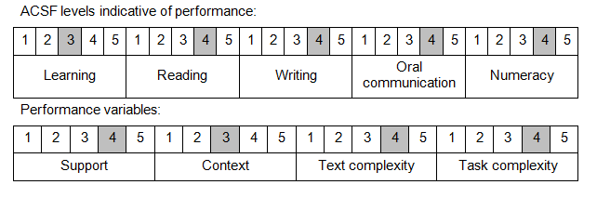

Further information on ACSF and the foundation skills underpinning this unit can be found in the Foundation Skills Guide on the GSA website.

Unit Mapping Information
This unit supersedes and is equivalent to DEFOH018 Conduct work health and safety inspections.

Links
Companion Volume implementation guides are found in VETNet - https://vetnet.gov.au/Pages/TrainingDocs.aspx?q=6bdbab1e-11ed-4bc9-9cba-9e1a55d4e4a9
Companion Volume implementation guides are found in VETNet - https://vetnet.gov.au/Pages/TrainingDocs.aspx?q=6bdbab1e-11ed-4bc9-9cba-9e1a55d4e4a9
Companion Volume implementation guides are found in VETNet - https://vetnet.gov.au/Pages/TrainingDocs.aspx?q=6bdbab1e-11ed-4bc9-9cba-9e1a55d4e4a9

