DEFWHS006 Develop ionising radiation safety plans
Release: 1

DEFWHS006 Develop ionising radiation safety plans

Modification History
Release | Comments
1 | This unit was released in DEF Defence Training Package release 1.0 and meets the Standards for Training Packages.  This unit supersedes and is equivalent to DEFOH008B Develop ionising radiation safety plans.  - Unit code updated  - Content and formatting updated to comply with the new standards  - All PC transitioned from passive to active voice  - PC 2.2 removed  - Elements 1 and 2 merged  - Element 1 one new PC

Application
This unit describes the skills required to measure and analyse ionising radiation and to develop relevant safety plans and procedures. In the context of this unit, ionising radiation may include emissions from radioactive elements, controlled apparatus, sealed and unsealed sources. The unit includes developing and drafting policy, procedures and plans/instructions for the management, amelioration and/or control of ionising radiation in the workplace.
This was developed for those working in Defence involved in developing ionising radiation safety plans as a workplace responsibility, but is applicable to all individuals who work in this field.
The skills and knowledge described in this unit must be applied within the legislative, regulatory and policy environment in which they are carried out. Organisational policies and procedures must be consulted and adhered to.
Those undertaking this unit would work independently or as part of a team under, indirect supervision. They must be able to use discretion and judgement and take responsibility for the quality of their outputs. They would perform complex tasks in a range of familiar contexts.
No licensing, legislative or certification requirements apply to unit at the time of publication.

Competency Field
Work Health & Safety

Elements and Performance Criteria
ELEMENTS | PERFORMANCE CRITERIA
Elements describe the essential outcomes | Performance criteria describe the performance needed to demonstrate achievement of the element. Where bold italicised text is used, further information is detailed in the range of conditions section.
1. Prepare for the development of ionising radiation safety plans | 1.1 Identify and confirm ionising radiation sources.  1.2 Identify and access standards and legislation appropriate to ionising radiation exposure levels.  1.3 Identify and access existing organisational records relevant to ionising radiation.  1.4 Identify, acquire and prepare equipment and resources required for the measurement of ionising radiation.  1.5 Measure ionising radiation.  1.6 Deploy measuring equipment and record readings.
2. Analyse ionising radiation | 2.1 Interpret and confirm measurements.  2.2 Analyse and/or determine ionising radiation and report findings to appropriate authorities/superiors.
3. Develop ionising radiation safety plans | 3.1 Conduct consultation with stakeholders.  3.2 Identify and interpret technical standards, organisational environmental requirements and ionising radiation exposure levels.  3.3 Develop ionising radiation safety plans.  3.4 Forward ionising radiation safety plans.
4. Record and interpret data from personal monitors | 4.1 Record full exposure data from personal monitors.  4.2 Provide access to individual records to the radiation worker.  4.3 Initiate action whenever anomalous records are obtained.  4.4 Review personal monitoring records regularly and provide recommendations for changes in workplace procedures as appropriate.

Foundation Skills
The foundation skills demands of this unit have been mapped for alignment with the Australian Core Skills Framework (ACSF). The following tables outline the performance levels indicated for successful attainment of the unit.

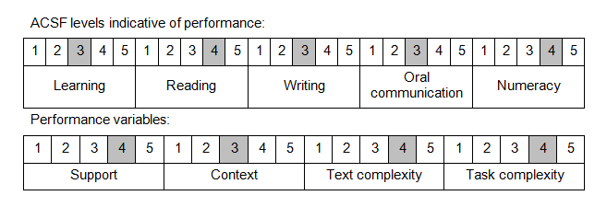

Further information on ACSF and the foundation skills underpinning this unit can be found in the Foundation Skills Guide on the GSA website.

Unit Mapping Information
This unit supersedes and is equivalent to DEFOH008B Develop ionising radiation safety plans.

Links
Companion Volume implementation guides are found in VETNet - https://vetnet.gov.au/Pages/TrainingDocs.aspx?q=6bdbab1e-11ed-4bc9-9cba-9e1a55d4e4a9
Companion Volume implementation guides are found in VETNet - https://vetnet.gov.au/Pages/TrainingDocs.aspx?q=6bdbab1e-11ed-4bc9-9cba-9e1a55d4e4a9
Companion Volume implementation guides are found in VETNet - https://vetnet.gov.au/Pages/TrainingDocs.aspx?q=6bdbab1e-11ed-4bc9-9cba-9e1a55d4e4a9

