DEFWHS004 Develop radio frequency radiation safety plans
Release: 1

DEFWHS004 Develop radio frequency radiation safety plans

Modification History
Release | Comments
1 | This unit was released in DEF Defence Training Package release 1.0 and meets the Standards for Training Packages.  This unit supersedes and is equivalent to DEFOH006B Develop radio frequency radiation safety plans.  - Unit code updated  - Content and formatting updated to comply with the new standards  - All PC transitioned from passive to active voice  - PC 2.2 removed  - Elements 1 and 2 merged  - Element 1 one new PC

Application
This unit describes the skills required to measure and analyse radio frequency radiation, including microwaves, radar and radio transmissions, and to develop relevant safety plans and procedures. This includes developing and drafting policy, procedures and plans/instructions for the management, amelioration and/or control of radio frequency radiation in the workplace.
This unit was developed for Defence workers involved in developing radio frequency safety plans as a workplace responsibility, but is applicable to all individuals who work in this field.
The skills and knowledge described in this unit must be applied within the legislative, regulatory and policy environment in which they are carried out. Organisational policies and procedures must be consulted and adhered to.
Those undertaking this unit would work independently or as part of a team, under indirect supervision. They must be able to use discretion and judgement and take responsibility for the quality of their outputs. They would perform complex tasks in a range of familiar contexts.
No licensing, legislative or certification requirements apply to unit at the time of publication.

Competency Field
Work Health & Safety

Elements and Performance Criteria
ELEMENTS | PERFORMANCE CRITERIA
Elements describe the essential outcomes | Performance criteria describe the performance needed to demonstrate achievement of the element. Where bold italicised text is used, further information is detailed in the range of conditions section.
1. Prepare to develop radio frequency radiation safety plans | 1.1 Identify and confirm radio frequency radiation sources.  1.2 Identify and access standards and legislation appropriate to radio frequency radiation exposure levels.  1.3 Identify and access existing organisational records relevant to radio frequency radiation.  1.4 Identify, acquire and prepare equipment and resources required for the measurement of radio frequency radiation.  1.5 Measure radio frequency radiation.  1.6 Deploy measuring equipment and record readings.
2. Analyse radio frequency radiation | 2.1 Interpret and confirm measurements.  2.2 Analyse and/or determine radio frequency radiation and report findings to appropriate authorities/superiors.
3. Develop radio frequency radiation safety plans | 3.1 Conduct consultation with stakeholders.  3.2 Identify and interpret technical standards, organisational environmental requirements and radio frequency radiation exposure levels.  3.3 Develop radio frequency radiation safety plans and forward to the relevant authority.

Foundation Skills
The foundation skills demands of this unit have been mapped for alignment with the Australian Core Skills Framework (ACSF). The following tables outline the performance levels indicated for successful attainment of the unit.

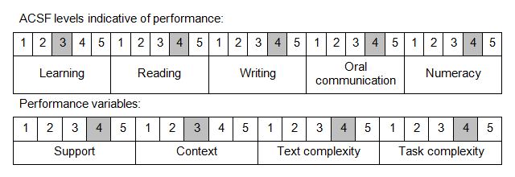

Further information on ACSF and the foundation skills underpinning this unit can be found in the Foundation Skills Guide on the GSA website.

Range of Conditions
Relevant organisational policies and procedures include: | - Australian or international standards (particularly AS/NZS 1269.2:1998 Occupational Radio Frequency Management, Part 2: Radio Frequency control management)  - manufacturer’s instructions  - state/territory/Commonwealth legislation

Unit Mapping Information

Links
Companion Volume implementation guides are found in VETNet - https://vetnet.gov.au/Pages/TrainingDocs.aspx?q=6bdbab1e-11ed-4bc9-9cba-9e1a55d4e4a9
Companion Volume implementation guides are found in VETNet - https://vetnet.gov.au/Pages/TrainingDocs.aspx?q=6bdbab1e-11ed-4bc9-9cba-9e1a55d4e4a9
Companion Volume implementation guides are found in VETNet - https://vetnet.gov.au/Pages/TrainingDocs.aspx?q=6bdbab1e-11ed-4bc9-9cba-9e1a55d4e4a9

