DEFTST005 Produce test and evaluation reports
Release: 1

DEFTST005 Produce test and evaluation reports

Modification History
Release | Comments
1 | This unit was released in DEF Defence Training Package release 1.0 and meets the Standards for Training Packages.  This unit supersedes and is equivalent to DEFTE005A Produce test and evaluation reports.  - Unit code updated  - Content and formatting updated to comply with the new standards  - All PC transitioned from passive to active voice

Application
This unit describes the skills required to compile a report on a test and evaluation process. It includes determining the report structure and presenting results.
This unit was developed for Defence test and evaluation workers, but is applicable to any individuals who work in this field.
The skills and knowledge described in this unit must be applied within the legislative, regulatory and policy environment in which they are carried out. Organisational policies and procedures must be consulted and adhered to.
Those undertaking this unit would work independently or as part of a team, under direct and indirect supervision, use discretion and judgement, and take responsibility for the quality of their output. They would perform complex tasks in a range of contexts.
No licensing, legislative or certification requirements apply to unit at the time of publication.

Competency Field
Testing

Elements and Performance Criteria
ELEMENTS | PERFORMANCE CRITERIA
Elements describe the essential outcomes | Performance criteria describe the performance needed to demonstrate achievement of the element. Where bold italicised text is used, further information is detailed in the range of conditions section.
1. Determine report structure | 1.1 Collate input from stakeholders and test participants.  1.2 Analyse and select most appropriate communication means.  1.3 Select report structure and format.  1.4 Select categories and logical sequences of data, information and knowledge to achieve report objectives.  1.5 Develop overview of report structure and content.
2. Draft report | 2.1 Collate, interpret and summarise data, information and knowledge to prepare text that satisfies report purposes and objectives.  2.2 Maintain security and confidentiality of data.  2.3 Include multimedia as appropriate to report purposes and objectives.  2.4 Identify and action gaps in required data and information.  2.5 Use language and writing styles appropriate to audience and that clearly reports purposes and objectives.  2.6 Use appropriate software to apply design elements to texts that satisfies report purposes and objectives.  2.7 Circulate draft report for comment to stakeholders and test participants.
3. Prepare and distribute final report | 3.1 Incorporate amendments from comments.  3.2 Check grammar, spelling, punctuation and style for accuracy.  3.3 Approve report by stakeholders.  3.4 Produce and distribute report.

Foundation Skills
The foundation skills demands of this unit have been mapped for alignment with the Australian Core Skills Framework (ACSF). The following tables outline the performance levels indicated for successful attainment of the unit.

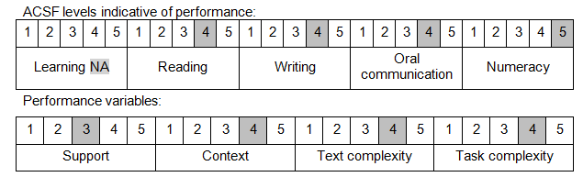

Further information on ACSF and the foundation skills underpinning this unit can be found in the Foundation Skills Guide on the GSA website.

Unit Mapping Information
This unit supersedes and is equivalent to DEFTE005A Produce test and evaluation reports.

Links
Companion Volume implementation guides are found in VETNet - https://vetnet.gov.au/Pages/TrainingDocs.aspx?q=6bdbab1e-11ed-4bc9-9cba-9e1a55d4e4a9
Companion Volume implementation guides are found in VETNet - https://vetnet.gov.au/Pages/TrainingDocs.aspx?q=6bdbab1e-11ed-4bc9-9cba-9e1a55d4e4a9
Companion Volume implementation guides are found in VETNet - https://vetnet.gov.au/Pages/TrainingDocs.aspx?q=6bdbab1e-11ed-4bc9-9cba-9e1a55d4e4a9

