DEFTRP005 Operate a multi-axle trailer
Release: 1

DEFTRP005 Operate a multi-axle trailer

Modification History
Release | Comments
1 | This unit was released in DEF Defence Training Package release 1.0 and meets the Standards for Training Packages.  This unit supersedes and is equivalent to DEFTP005B Operate a multi-axle trailer.  - Unit code updated  - Content and formatting updated to comply with the new standards  - All PC transitioned from passive to active voice  - Element 1 reworded

Application
This unit describes the skills required to configure, load, tow, manoeuvre and unload a multi-axle trailer coupled to a wheeled vehicle authorised to tow this type of trailer. Multi-axle trailers in this context are used to transport wheeled and tracked vehicles, containers and items of general cargo in a range of operating environments.
This unit was developed for military drivers in a threat environment, but is applicable to any individuals who work in this field.
The skills and knowledge described in this unit must be applied within the legislative, regulatory and policy environment in which they are carried out. Organisational policies and procedures must be consulted and adhered to.
Those undertaking this unit would work independently or as part of a team, under direct and indirect supervision, use discretion and judgement, and take responsibility for the quality of their output. They would perform routine tasks in a broad range of unpredictable contexts.
No licensing, legislative or certification requirements apply to unit at the time of publication.

Competency Field
Transport

Elements and Performance Criteria
ELEMENTS | PERFORMANCE CRITERIA
Elements describe the essential outcomes | Performance criteria describe the performance needed to demonstrate achievement of the element. Where bold italicised text is used, further information is detailed in the range of conditions section.
1. Prepare to tow a multi-axle trailer | 1.1 Conduct serviceability check of the trailer.  1.2 Rectify and/or report faults.  1.3 Prepare and configure trailer to meet the requirements of the load/cargo.  1.4 Load trailer with different types of loads.  1.5 Secure and protect load.
2. Tow a multi-axle trailer | 2.1 Couple and uncouple multi-axle trailer to a vehicle.  2.2 Tow multi axle trailer.
3. Refurbish a multi-axle trailer | 3.1 Unload multi-axle trailer on completion of the task.  3.2 Conduct serviceability and damage checks.  3.3 Rectify and/or report faults.

Foundation Skills
The foundation skills demands of this unit have been mapped for alignment with the Australian Core Skills Framework (ACSF). The following tables outline the performance levels indicated for successful attainment of the unit.

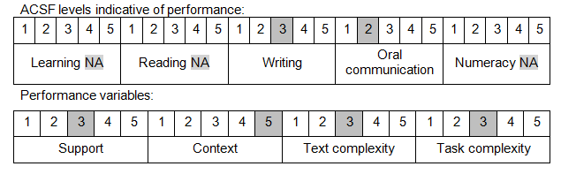

Further information on ACSF and the foundation skills underpinning this unit can be found in the Foundation Skills Guide on the GSA website.

Unit Mapping Information
This unit supersedes and is equivalent to DEFTP005B Operate a multi-axle trailer.

Links
Companion Volume implementation guides are found in VETNet - https://vetnet.gov.au/Pages/TrainingDocs.aspx?q=6bdbab1e-11ed-4bc9-9cba-9e1a55d4e4a9
Companion Volume implementation guides are found in VETNet - https://vetnet.gov.au/Pages/TrainingDocs.aspx?q=6bdbab1e-11ed-4bc9-9cba-9e1a55d4e4a9
Companion Volume implementation guides are found in VETNet - https://vetnet.gov.au/Pages/TrainingDocs.aspx?q=6bdbab1e-11ed-4bc9-9cba-9e1a55d4e4a9

